**Aircraft Price Prediction using Multiple Linear Regression Model**

Group 3 – Project Final Report

Anitha Joseph - 30282217

Jincy Thomas - 30271046

Joshua Quartey - 30263911

Megha Radhakrishnan Sanitha - 30272516

Prichelle Lal - 30261130

Riya Chevli - 30272176

**1. INTRODUCTION**

------------------------------

* 1. **MOTIVATION**
     1. **Context**

This project focuses on predicting the price of aircraft based on their technical specifications and performance metrics. The dataset contains 518 aircraft records, with price (in USD) as the target variable and 14 quantitative (e.g., speed, weight, range) and 2 qualitative (e.g., engine type) explanatory variables.

**Applied Domains**

**1.** **Aircraft Manufacturing and Sales**

* Helps manufacturers and dealers price aircraft based on performance.
* Supports competitive pricing by comparing similar models.

**2.** **Aviation Finance and Insurance**

* Assists banks and insurers in assessing fair market values for loans and coverage.
* Reduces risk in leasing and resale evaluations.

**3.** **Buyers and Fleet Operators**

* Helps airlines and private buyers compare costs and performance.
* Guides purchasing decisions by highlighting key price factors like engine power and range.

**4.** **Data Science and Predictive Modeling**

* Demonstrates regression techniques for selecting important features.
* Shows how machine learning can predict industrial pricing.
  + 1. **Problem**

The problem revolves around understanding and predicting **aircraft pricing** based on a variety of performance and specification metrics, such as engine type, power, speed, weight, and range. Accurately predicting aircraft prices could optimize decision-making in manufacturing, purchasing, or maintenance planning. It could also highlight key features that drive pricing, helping stakeholders make more informed choices.

**Proposed Data/Visual Analytics Solution:**

1. **Data Analysis:**

* Use model selection procedures to identify key drivers of aircraft price, such as speed, range, and engine type.
* Explore correlations between features to better understand their impact on price.

1. **Visualization Techniques:**

* Develop scatter plots to visualize relationships between price and individual factors like engine power or speed.
* Use boxplots to compare price distributions by engine type or other qualitative variables.
* Build a correlation heatmap to uncover relationships between quantitative variables.
* Create residual plots to assess model performance and identify areas for improvement.

1. **Predictive Modeling:**

* Build the best possible regression model to predict aircraft price based on the given predictors.
* Visualize the model's performance through R² values, predicted vs. actual plots, and residual plots.
  + 1. **Challenges**

Aircraft pricing is a complex problem due to the interplay of multiple technical, operational, and market factors. The challenges arise from the following aspects:

* **Lots of Variables**: There are many factors (like engine power, speed, and fuel capacity) that affect price. These factors are interconnected, making it hard to figure out their individual impact. *Example*: Engine power and range might both affect the price, but it’s tricky to separate their influence.
* **Different Aircraft Types**: Aircraft models are very diverse in size, performance, and design. A single model may not work for all. *Example*: A small private plane and a large commercial jet have totally different pricing rules.
* **Missing Market Factors**: The dataset only includes technical details but not external factors like brand popularity or market demand, which can also influence pricing. *Example*: Two planes with similar specs might have different prices because of brand value.
* **Overlapping Factors**: Some variables (like speed and range) are closely related, making it hard to tell which one affects the price more. *Example*: A faster plane often has a longer range, so it’s tough to say which feature raises the price.
* **Categorical Data**: Some data, like engine type (piston vs. others), is not numerical, so it’s harder to analyze and might need special handling. *Example*: How do you measure the price effect of "piston engines" compared to "others"?

----------------------------

* 1. **OBJECTIVES**
     1. **Overview**

For this project, we aim to analyze various factors influencing aircraft pricing using the Aircraft Price Analysis & Prediction Dataset. Previous research on this subject has already proved that the price of the aircraft is dependent on certain characteristics of the aircraft. Al-Shammah and Ali[2024] has found that increasing the cruise speed increases the aircraft power and in turn, the price of the aircraft.

The main objective is to build a reliable model that predicts aircraft prices accurately based on technical specifications and performance characteristics.

Additionally, we aim to:

* Understand the relationship between aircraft features and their impact on price.
* Identify key factors that drive pricing.
* Provide insights that improve decision-making for manufacturers, buyers, and sellers in the aviation industry.

This project is important because the aviation industry plays a major role in the global economy. Price predictions and insights derived from this research can influence cost optimization, investment decisions, and business strategies. By addressing issues like heteroscedasticity and multicollinearity in the data, our approach will ensure a robust predictive model that aids in solving real-world aviation pricing challenges.

* + 1. **Goals & Research Questions**

1.2.2.1. Clean the dataset and check the basic linearity assumptions and

1.2.2.2. Apply Model Selection Procedures to find the best model

1.2.2.3. Model evaluation using adjusted R2 and residual standard error and p-values for significance.

1.2.2.3. Check the linearity assumptions on the best fit model

1.2.2.4. Fit the best model and interpretation of the coefficients to identify the key price drivers

1.2.2.5. Interval estimation for coefficients

1.2.2.6. Model Prediction

**2. Methodology**

* 1. **Data**

Prices for 518 different aircraft are given in aircraft_price.csv file. The dataset includes 517 aircraft records with 14 quantitative variables and 2 qualitative variables. Quantitative Variables are measured on a continuous ratio scale (e.g., speed in knots, weight in pounds, price in dollars) and Qualitative Variables are measured on a nominal scale (e.g., engine type as piston or other). The dataset contains a variety of aircraft performance and specification data, which could be useful for price prediction. The aircraft price varies by their engine type, power, fuel capacity, speed, weight, distance range and other parameters. The aircraft dataset we are using is open-source and hosted on Kaggle. However, the creator may have compiled it using data from the World Bank.

<https://www.kaggle.com/datasets/mehmet0sahinn/aircraft-price-analysis-and-prediction-dataset?resource=download>

* **Dependent Variable**:
  + **price**: Aircraft price in US dollars (quantitative, continuous).
* **Explanatory Variables**:
  + **model_name**: Name of the aircraft model (qualitative, identifier).
  + **engine_type**: Type of engine (e.g., Piston, Propjet; qualitative, nominal).
  + **engine_power**: Engine power measured in horsepower (quantitative, ratio scale).
  + **max_speed**: Maximum speed of the aircraft in knots (quantitative, ratio scale).
  + **cruise_speed**: Cruise speed of the aircraft in knots (quantitative, ratio scale).
  + **stall_speed**: Minimum speed to prevent stalling, measured in knots (quantitative, ratio scale).
  + **fuel_tank**: Fuel tank capacity in gallons (quantitative, ratio scale).
  + **all_eng_roc**: Rate of climb with all engines, measured in feet/min (quantitative, ratio scale).
  + **out_eng_roc**: Rate of climb with one engine out, measured in feet/min (quantitative, ratio scale).
  + **takeoff_distance**: Minimum distance required for takeoff in feet (quantitative, ratio scale).
  + **landing_distance**: Minimum distance required for landing in feet (quantitative, ratio scale).
  + **empty_weight**: Empty weight of the aircraft in pounds (quantitative, ratio scale).
  + **length**: Length of the aircraft in inches (quantitative, ratio scale).
  + **wing_span**: Wingspan of the aircraft in inches (quantitative, ratio scale).
  + **range**: Maximum distance the aircraft can travel on a full tank in nautical miles (quantitative, ratio scale).
  1. **Approach**

Approach for Data/Visual Analytics Solution:

1. **Data Exploration and Cleaning**:

To understand the dataset and handle missing or inconsistent data.

1. **Feature Analysis and Engineering:**

Analyze relationships between variables using correlation heatmaps and scatter plots to identify significant predictors of aircraft price.

1. **Data Visualization**

Use scatter plots, boxplots, and bar charts to highlight the relationships between price and key variables like engine type, speed, and range. Incorporate more complex visualizations, such as 3D plots, to explore multivariate relationships.

1. **Model Development:**

Build predictive models (e.g., linear regression, multiple regression) to estimate aircraft price using both quantitative and qualitative variables. Apply regression techniques like forward/backward/stepwise selection to refine the model and identify the most relevant predictors.

1. **Performance Evaluation:**

Evaluate model performance using metrics such as R², Adjusted R², residual standard error, and p-values. Validate the model by splitting the data into training and test sets and comparing predictions to actual values.

1. **Outlier and Assumption Checks**:

Identify and address outliers and ensure assumptions like linearity, independence, and homoscedasticity are satisfied. Use residual plots to visually check model assumptions

* 1. **Workflow**

The main workflow for our project is listed in the flow chart below. Meeting the Equal Variance assumption was quite time consuming and need more work to be done to resolve the issue. Even if the multicollinearity is not detected in our data set, some of the VIF values for some significant predictors were greater than 5. Further analysis is necessary to evaluate those predictors relevance. If we drop engine power and cruise speed, we lose theoretical significance in predicting the price. So, for time being we kept those predictors in our model.

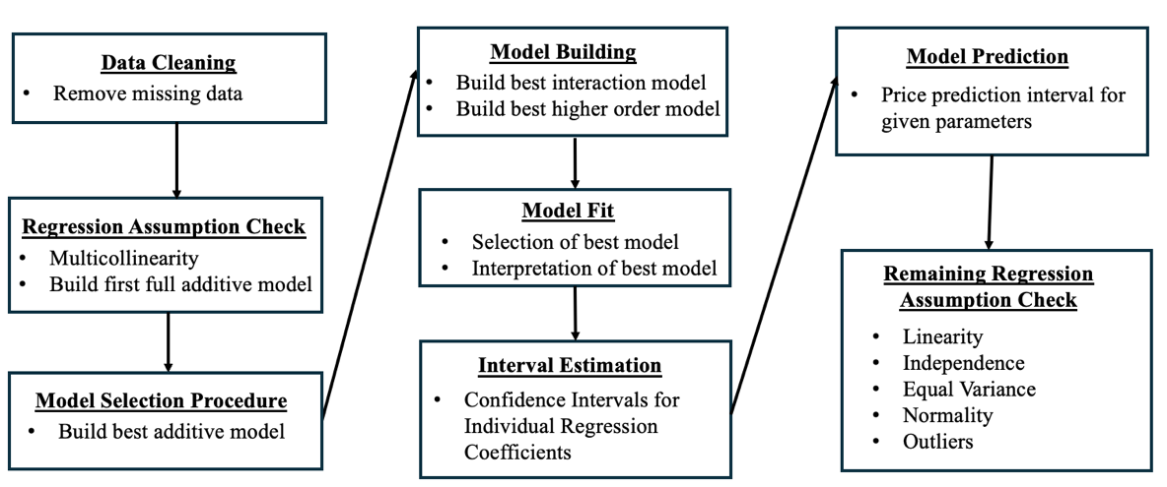

* 1. **Contributions**

|  |  |  |
| --- | --- | --- |
| **#** | **TASKS LIST** | **Contributors** |
| 1 | Data Cleaning | Jincy |
| 2 | **Checking The Regression Assumption**: Multicollinearity | Anitha |
| 3 | **Model Selection Procedures**: Find Best Additive Model | Riya, Anitha, Jincy |
| 4 | **Model Building** |  |
| i | Best Interaction Model | Joshua |
| ii | Best Higher Order Model | Megha, Jincy, Anitha |
| iii | **Model Selection**: Choose Best Model | Jincy, Anitha |
| 5 | **Model Fit** |  |
| i | Selection Of Best Model | Jincy |
| ii | Interpretation Of Best Model | Riya, Jincy |
| 6 | Interval Estimation | Prichelle |
| 7 | Model Prediction | Riya |
| 8 | **Checking Remaining Regression Assumptions** |  |
| i | Independence Assumption | Megha |
| ii | Linearity Assumption | Megha |
| iii | Equal Variance Assumption | Joshua |
| iv | Normality Assumption | Prichelle |
| v | Outliers | Riya, Jincy, Anitha |
| 8 | RMD file consolidation | Anitha, Jincy |
| 9 | Final Report preparation | Jincy, Megha, Anitha |
| 9 | PPT template creation | Prichelle |
| 10 | Final PPT preparation | Everyone |
| 11 | Review and editing of final report | Prichelle,Riya, Joshua |

1. **MAIN RESULTS OF THE ANALYSIS**
   1. **Results**

There were 517 rows in the dataset, and 10 rows with missing price values were removed.

**3.1.1 Regression Assumption check – Testing for Multicollinearity**

Testing Multicollinearity for the model with all the predictor variables to find correlated predictor variables.

We have used scatter plots between independent predictors and VIF test to detect multicollinearity.

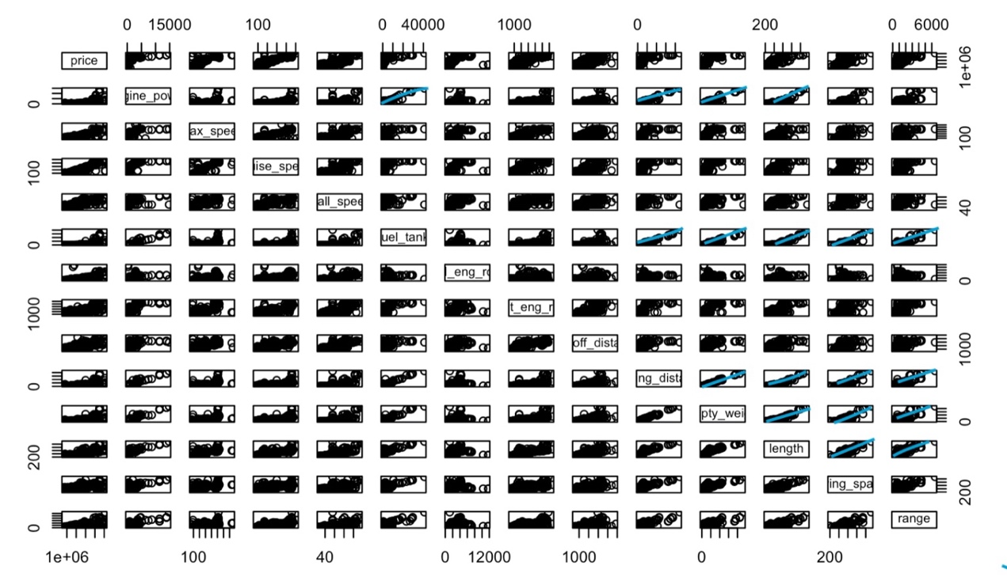

Figure3.1 Pairs plot for the linear regression model with all the predictor variables

From this pairs plot, we can see that there exists correlation for engine_power with landing_distance, empty_weight and fuel_tank respectively. Also there exists a correlation between wing_span and length.

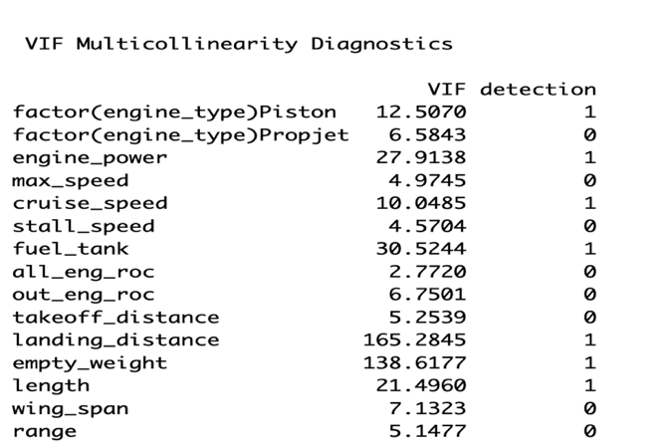

Figure 3.2 R output for VIF for the model with all the predictor variables

Multicollinearity is detected for factor(engine_type)Piston, engine_power,cruise_speed,fuel_tank landing_ distance, empty_weight and length. So, we have to improve our model by removing the variables step by step. VIF is valid for numerical predictor variables only. VIFs for the categorical predictor engine_type is not valid.

**3.1.2 Choosing best Model without Multicollinearity**

The model we obtained after removing the predictors with high VIF has 10 predictor variables.

price ~ factor(engine_type)+engine_power + max_speed + cruise_speed +stall_speed + all_eng_roc + out_eng_roc + takeoff_distance + wing_span + range

The VIF detected for engine_power and cruise speed are greater than 5, but the multicollinearity detection is zero.

Engine power and cruise_speed are logically and statistically a significant predictor for predicting the price of an aircraft. So, we decided to keep them in our model. And the adjusted R squared value of the model obtained after removing cruise_speed was found to be lesser than the corresponding value of the model with the cruise_speed variable. So, we decided to take this model as the base model for selecting the best model.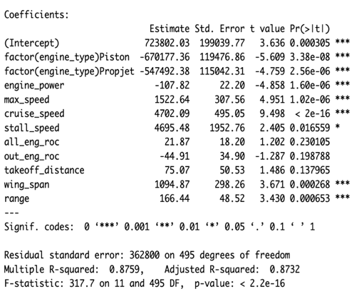 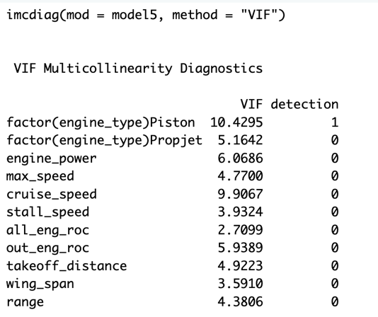

Figure 3.3 Summary of the selected model

Figure 3.4 VIF

|  |  |  |
| --- | --- | --- |
| **Model** | **Adjusted R^2** | **RSE** |
| without cruise speed | 0.8452 | 400800 |
| without engine_power | 0.8366 | 411800 |
| with engine_power and cruise_speed | 0.8729 | 363200 |

Table 3.1 Adjusted R^2 and RSE values for different derived from the selected model

**3.2 Model Selection – Finding the best additive model from the model**

**3.2.1 Stepwise Selection Procedure**

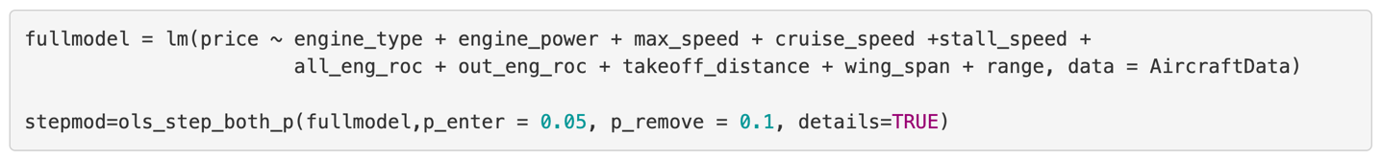

Figure 3.5 R Code for step_wise selection

$\hat{\text{price}}$ = 693659.32 - 661350.47Xengine_typePiston - 527735.55Xengine_typePropjet - 115.72Xengine_power + 1571.61Xmax_speed + 4963.33Xcruise_speed + 5401.47Xstall_speed + 1104.12Xwing_span + 159.60Xrange

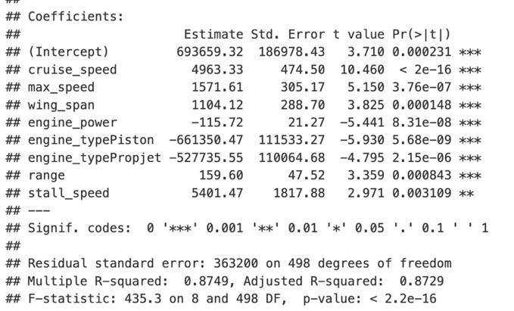

Figure 3.6 Summary of best model obtained using Stepwise selection procedure

### **3.2.2 Forward Selection Procedure**



Figure 3.6 R Code for forward selection procedure

Best additive model using Forward Selection Procedure is given by the regression equation:

$\hat{\text{price}}$ = 693659.32 - 661350.47Xengine_typePiston - 527735.55Xengine_typePropjet - 115.72Xengine_power + 1571.61Xmax_speed + 4963.33Xcruise_speed + 5401.47Xstall_speed + 1104.12Xwing_span + 159.60Xrange

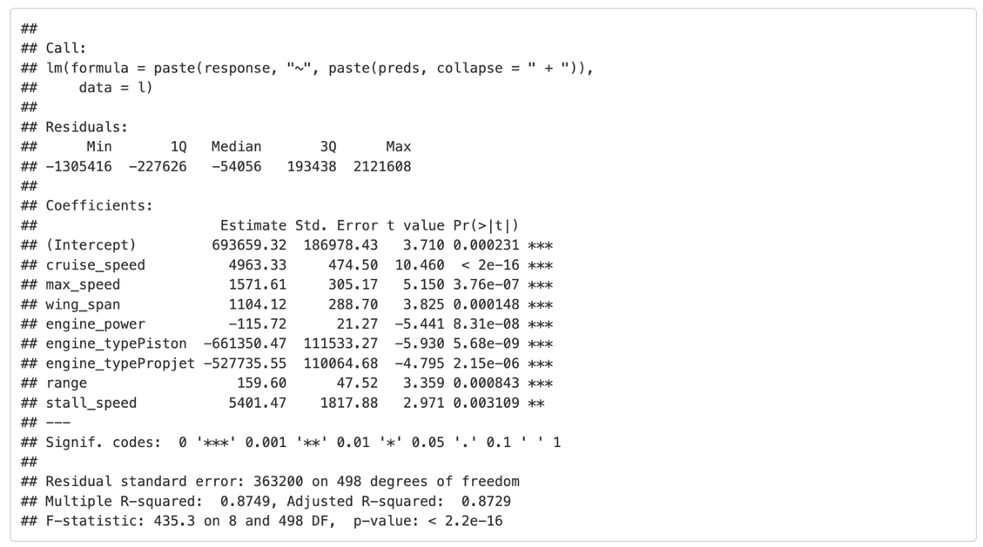

Figure 1.7 Summary of the model obtained from Forward Selection Procedure

The F-statistic value for testing the significance of the model is 435.3 and the p-value is much less than the significance value 0.05. So, the model is statistically significant.

### **3.2.3 Backwards Elimination**



Figure 3.8 R code for backwards elimination procedure

The Best additive model using the Backwards elimination procedure is given by the regression equation:

$\hat{\text{price}}$ = 693659.32 - 661350.47Xengine_typePiston - 527735.55Xengine_typePropjet - 115.72Xengine_power + 1571.61Xmax_speed + 4963.33Xcruise_speed + 5401.47Xstall_speed + 1104.12Xwing_span + 159.60Xrange

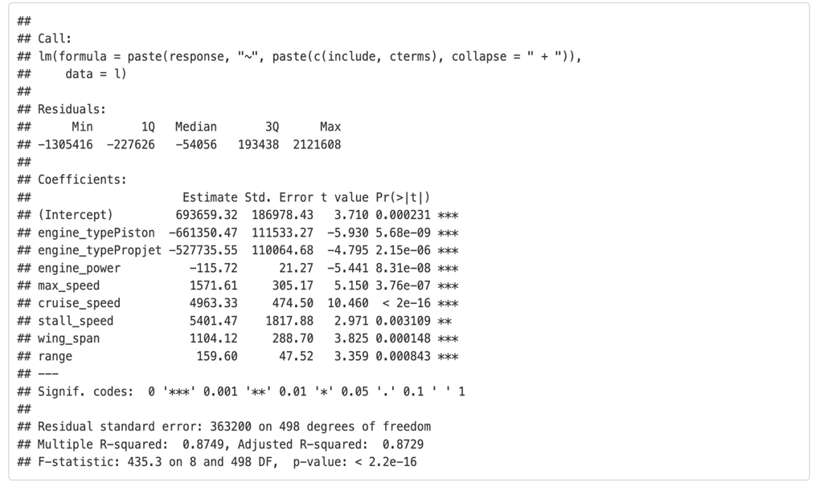

Figure 3.9 Summary of best model obtained from backwards elimination procedure

**3.2.4 All Possible Regressions Selection Procedure**

**3.2.4.1 All Possible Regressions Selection Procedure using ‘olsrr’ package**

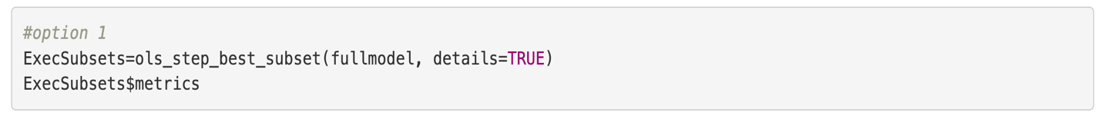

Figure 3.9 R code for All Possible Regressions Selection Procedure using olsrr library

Using option1(olsrr package): The the best model is the model, with CP = 10.15265 and AIC = 14431.78(smallest AIC) and predictors are: engine_type, engine_power, max_speed, cruise_speed, stall_speed, wing_span & range.

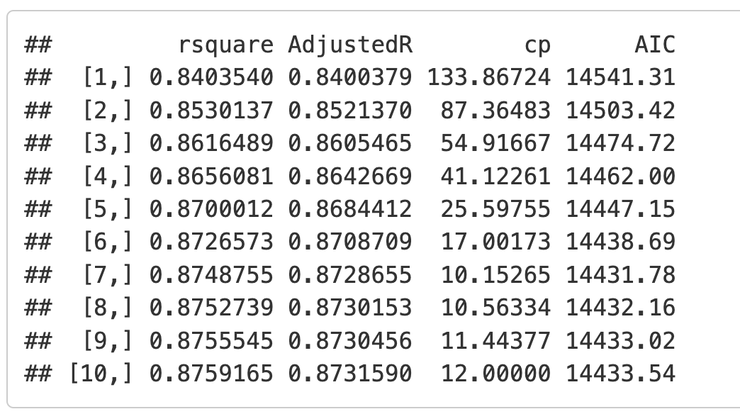

Figure 3.10 Selection criteria values for best models with different number of predictors using olsrr package

**3.2.4.2 All Possible Regressions Selection Procedure using ‘leaps’ package**

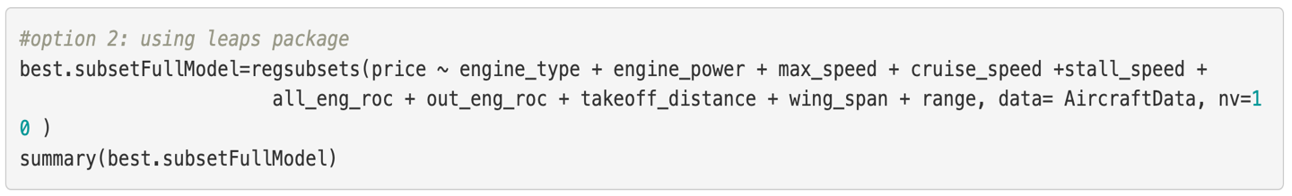

Figure 3.11 R code for All Possible Regressions Selection Procedure using leaps package

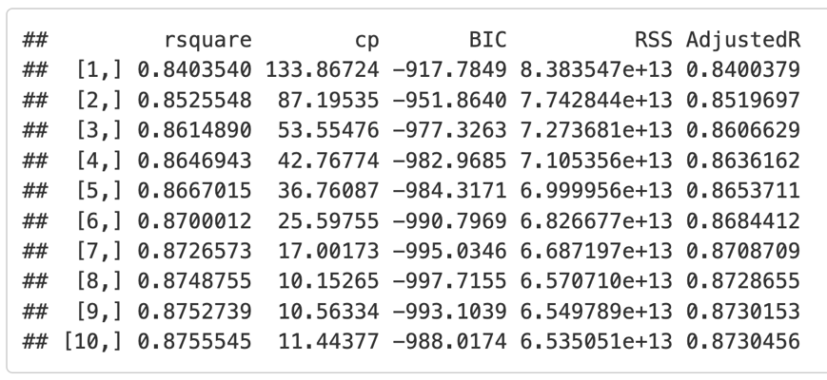

Figure 3.12 Selection criteria values for best models with different number of predictors using leaps package

Using the option2(with leaps package): The model with AdjustedR2 = 0.8728655, Mallow’sCP = 10.15265, BIC = -997.7155 is the best predictor and predictors are: engine_type, engine_power, max_speed, cruise_speed, stall_speed, wing_span & range.

All the predictor variables which are consistently selected for the best model are engine_type, engine_power, max_speed , cruise_speed , stall_speed , wing_span and range.

Thus, we can conclude that our best additive model will have the predictors engine_type, engine_power, max_speed, cruise_speed, stall_speed, wing_span and range for predicting the price of an aircraft. The model with these predictors can be used for building the interaction model.

The Best additive model chosen after comparing all these selection procedures is given by the regression equation:

$\hat{\text{price}}$ = 693659.32 - 661350.47Xengine_typePiston - 527735.55Xengine_typePropjet - 115.72Xengine_power + 1571.61Xmax_speed + 4963.33Xcruise_speed + 5401.47Xstall_speed + 1104.12Xwing_span + 159.60Xrange

**3.3 Selecting best Interaction Model**

**3.3.1 Building Full Interaction Model**

We build a full interaction model based on best additive model obtained from the previous step.

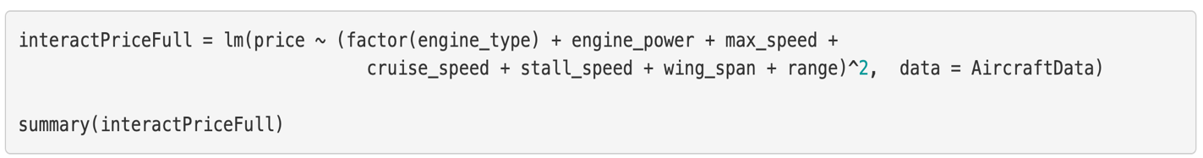

Figure 3.13 R code - model building

The summary of the full interaction model is given below:

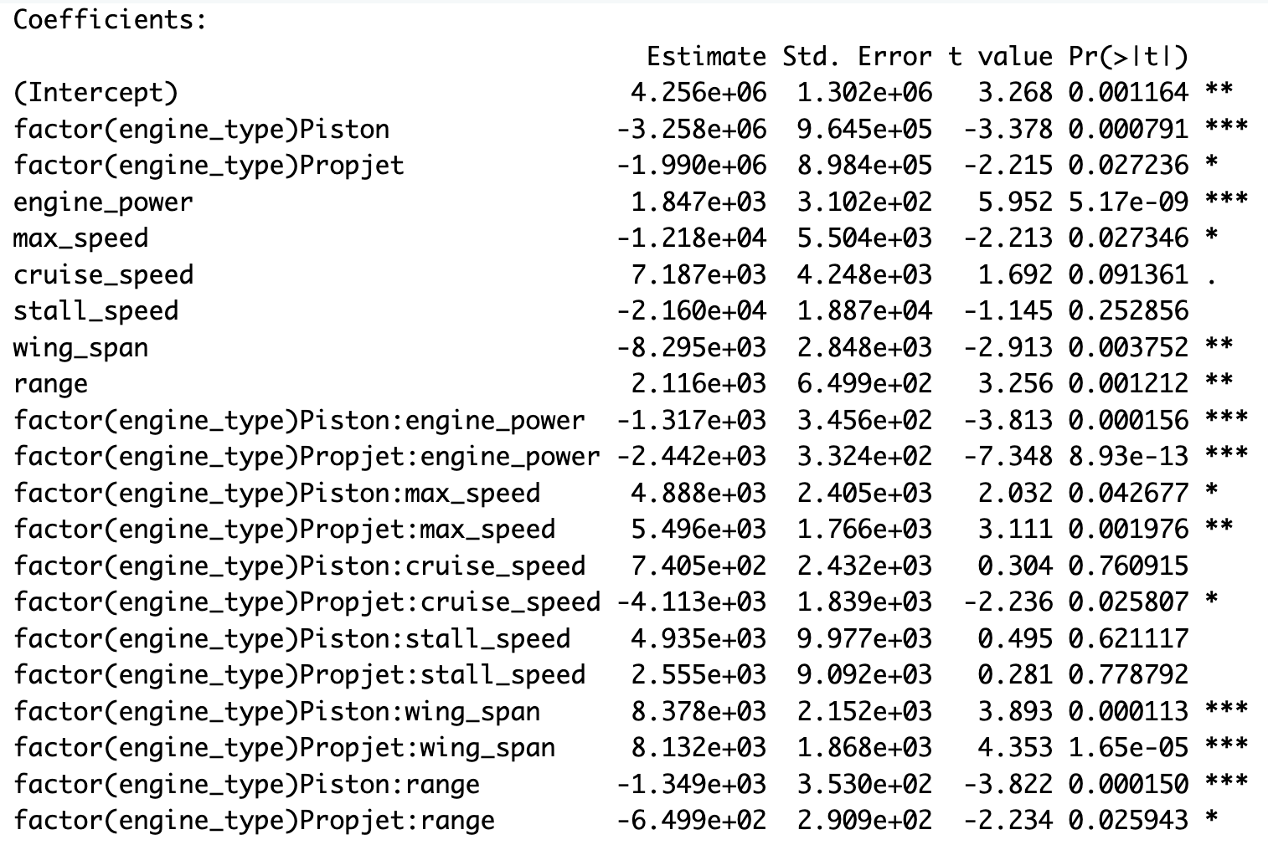

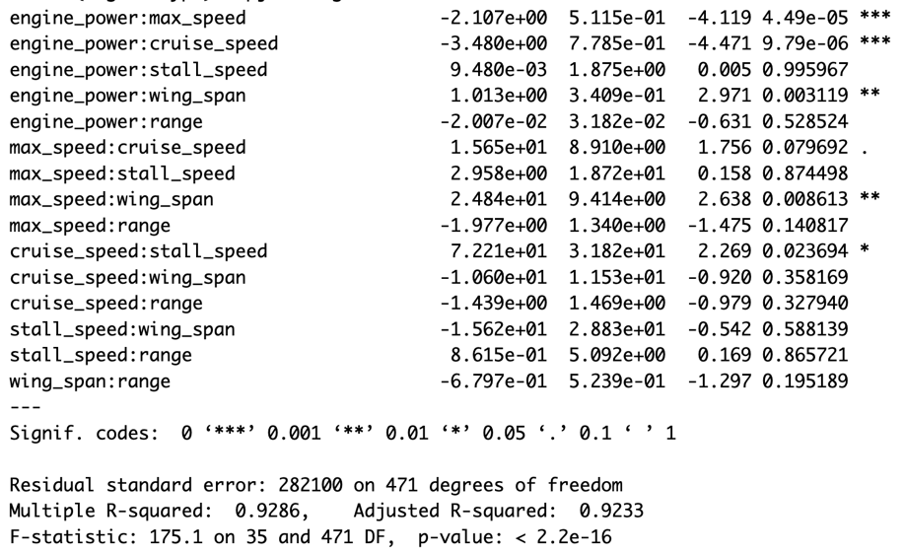

**3.3.2 Building Reduced Interaction Model**

We compared the p-values for each coefficients against the significance level 0.05 and dropped all the insignificant interaction terms(interaction term coefficients having p-values greater than 0.05) and build a new model with the significant terms.

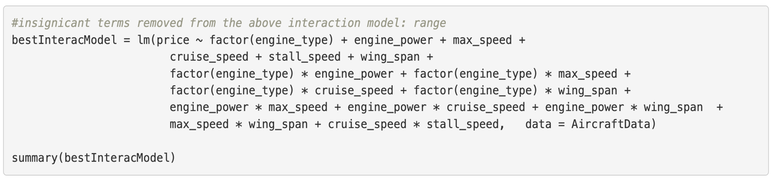

Figure 2.14 R code for creating model after removing insignificant terms

The summary of the new reduced interaction model is given below:

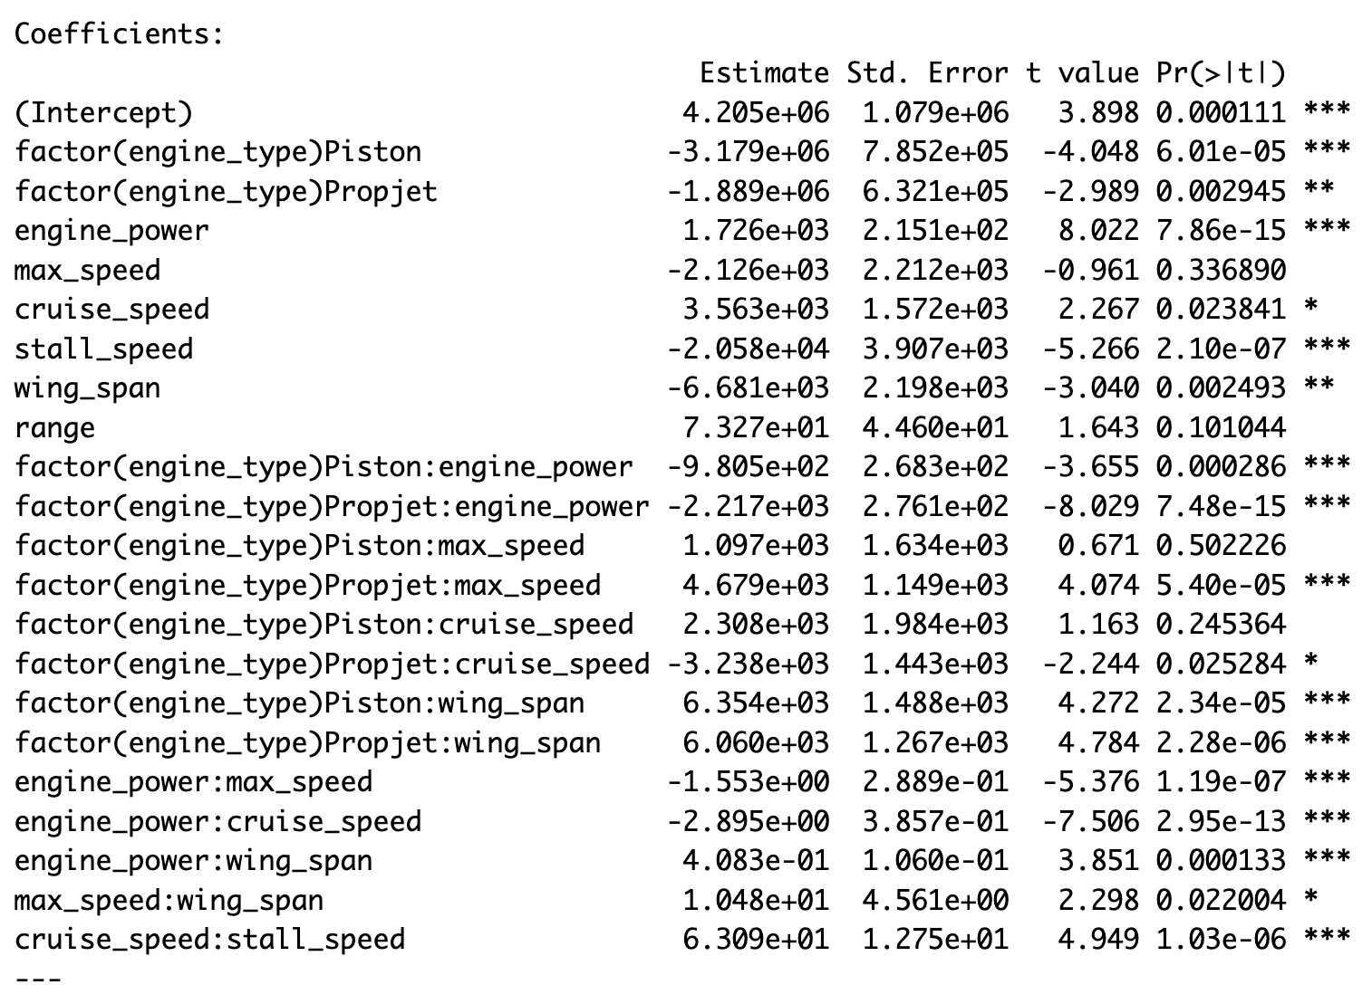

Residual standard error: 284800 on 486 degrees of freedom

Multiple R-squared: 0.9249,Adjusted R-squared: 0.9218

F-statistic: 299.3 on 20 and 486 DF,p-value: < 2.2e-16

**3.3.3 Selecting best Interaction Model Using ANOVA**

We have to test which model is to be taken as the best interaction model. So we can perform an ANOVA .

H0: the reduced model is the best

H1: the full interaction model is the best



Figure 3.15 R code for performing ANOVA to see the best interaction model

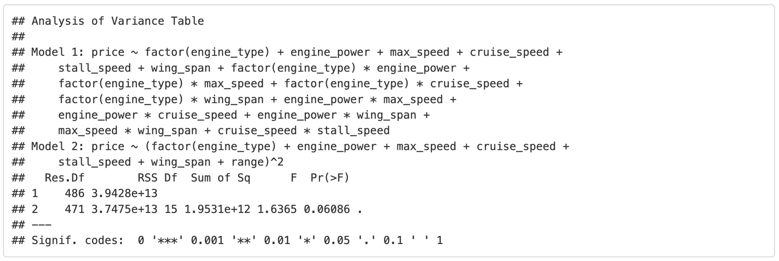

Figure 3.16 Result of Anova to find the best interaction model

From the above output, we can see that the p-value = 0.06086 > aplha(0.05). So we fail to reject the null hypothesis. Therefore we conclude that the reduced model is the better than the full interaction model and proceed with the reduced interaction model ‘bestInteracModel’

**3.3.4 Introducing Higher Order Terms in the Best Interaction Model**

We have to identify the higher order terms that should be added to the best interaction model for improving our model.

**Checking for non-linear relationships using the pairs plot**

We check if any of the independent variables has a non-linear relationship with the predictor variable.

Pairs plot is used for visualisation.

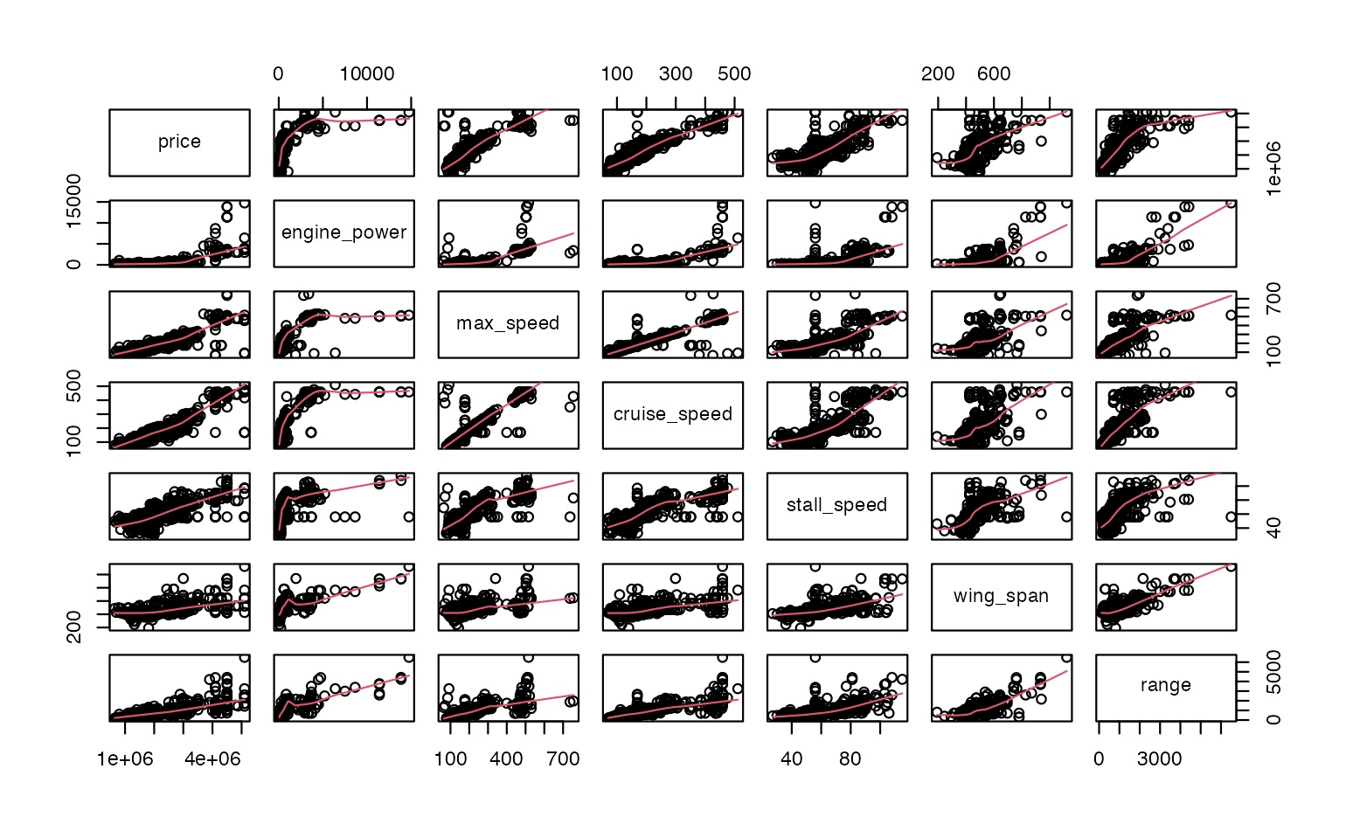

Figure 3.17 Pairs plot for identifying non-linear relationship of independent variables with the dependent variable price

From the pairs plot, we can see there might be a possibility for the predictor variables engine_power, max_speed and cruise_speed to have a non-linear relationship with the predicted ‘price’ variable.We have to take the predictors one by one and check for the significance of higher order terms.

### **Checking significance of higher order terms for the predictor ‘engine_power’**

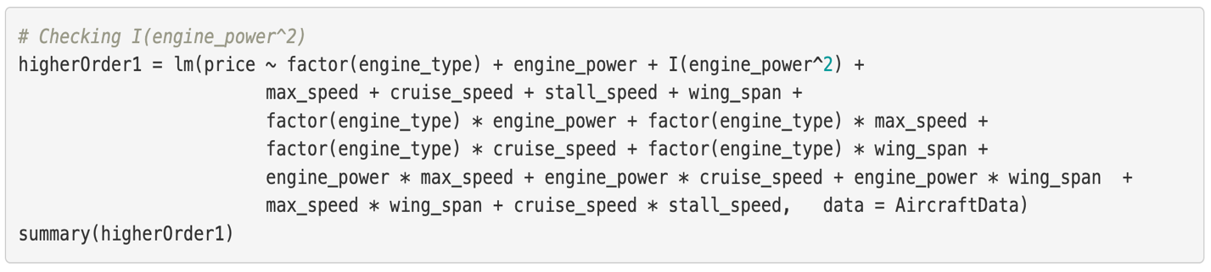

Figure 3.18 R code for checking if engine_power^2 is significant in predicting the price of an aircraft

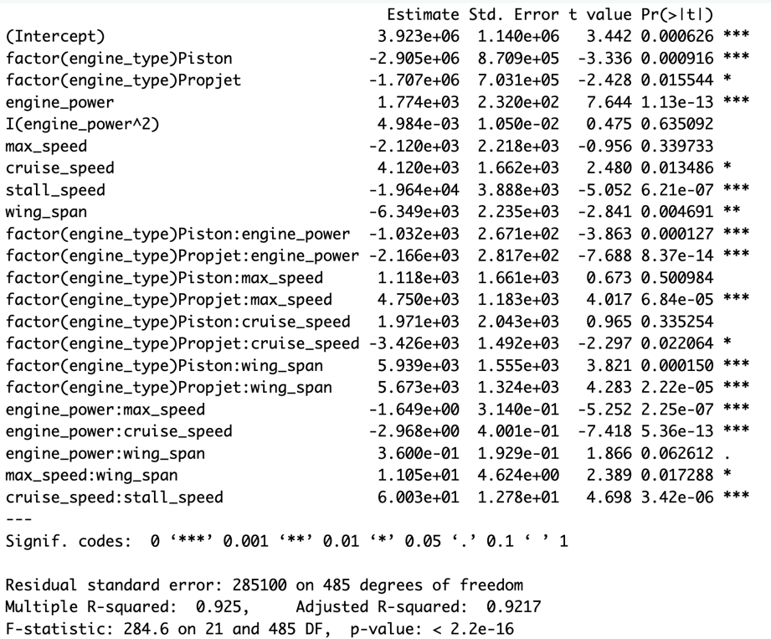

Figure 3.19 R output: Summary of model with quadratic term

H0: The coefficient of engine_power^2 is not significant.

H1: The coefficient of engine_power^2 is significant.

Since I(engine_power^2) is not significant with the p-value(0.635 which is greater than 0.05), we are moving to next step.

### **Checking higher order term for max_speed**

After finding that the quadratic term is significant for we check for the significance of the cubic term and find that the cubic term is significant. Upon checking for the significance of quatric term, we see that it is not significant and we stop the process, go back to the cubic term and check the summary of the model.

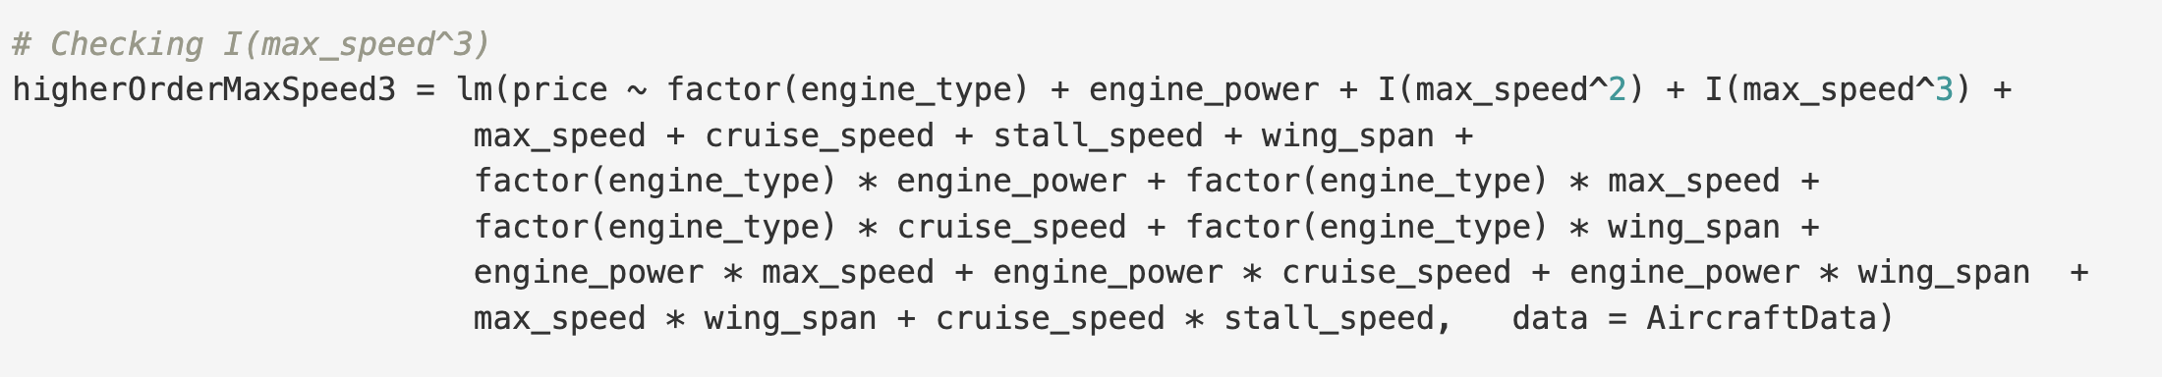

Figure 3.20 R code for building model with the cubic term for max_speed

The summary of the model is given below:

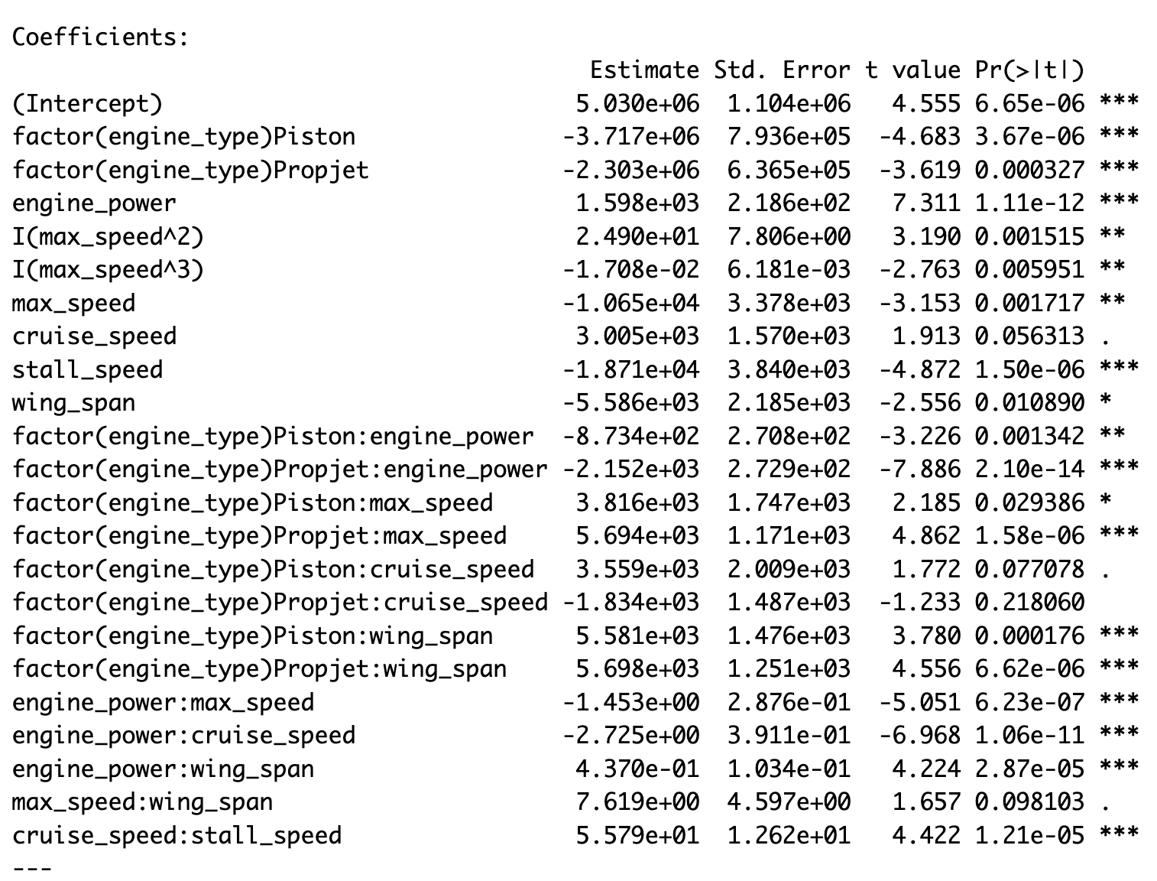

**Checking higher order terms for cruise_speed**

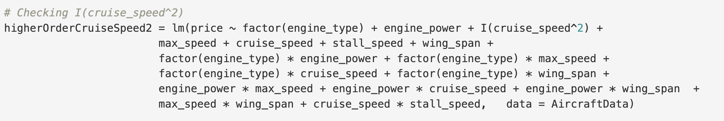

Figure 3.21 R code for creating a higher order model with cruise_speed^2

From the R output we find that the quadratic term is significant, and we proceed with the cubic term, but find it insignificant. So we stop the process and go back to the model with the quadratic term.

The summary of the model with the term cruise_speed^2 is given below:

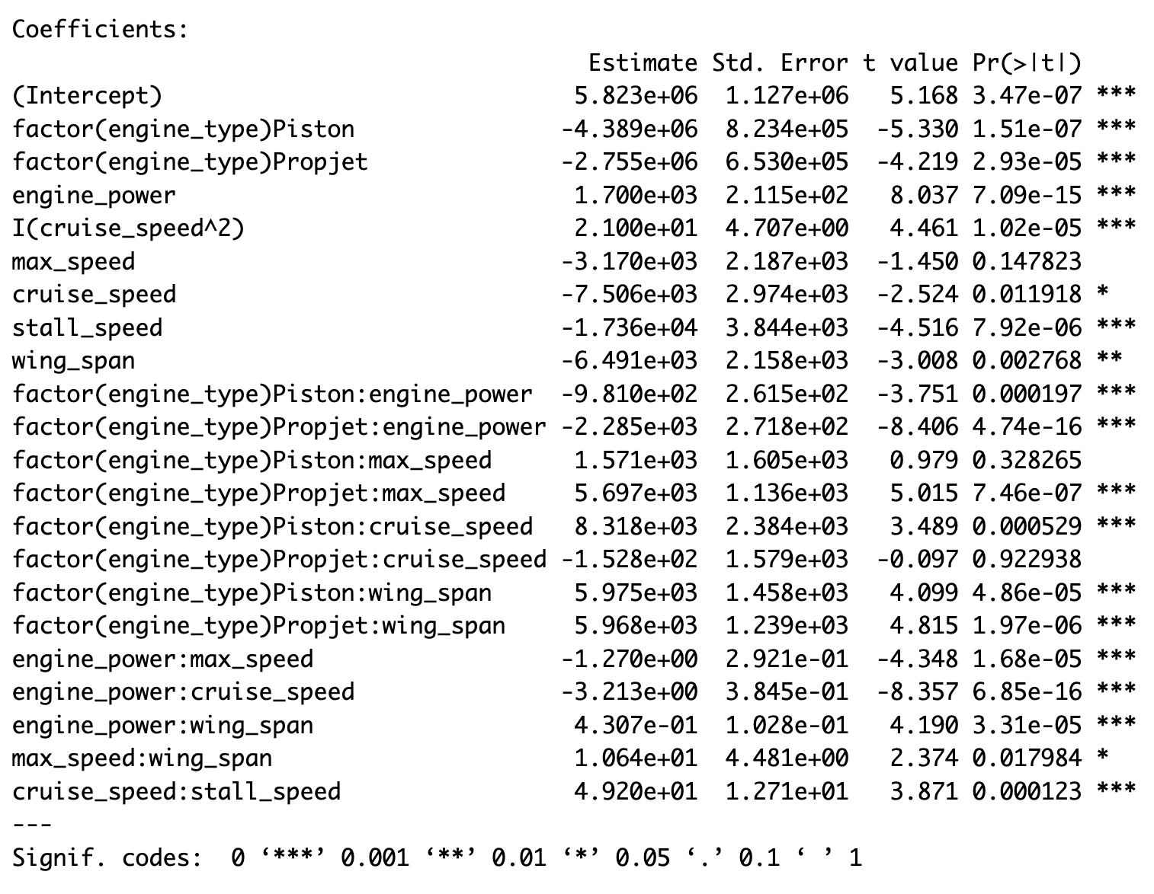

Residual standard error: 279400 on 485 degrees of freedom

Multiple R-squared: 0.9279,Adjusted R-squared: 0.9248

F-statistic: 297.1 on 21 and 485 DF, p-value: < 2.2e-16

Next, we tested the higher order terms of the predictor variable max_speed and compared it with the higher order terms of cruise_speed, and max_speed. However, we found that these terms become insignificant.

**Comparison of models with higher- order terms**

|  |  |  |
| --- | --- | --- |
| **Model** | **Adjusted R^2** | **RSE** |
| with max_speed^3 | 0.9238 | 281200 |
| with cruise_speed^2 | 0.9248 | 279400 |

Adjusted R squared is higher for ‘higherOrderCruiseSpeed2’ model (cruise_speed^2 above) and RSE is lower, so we could say that the ‘higherOrderCruiseSpeed2’ is the best model.

**3.4 Model Fit**

Here, we will compare the best interaction model and the higher order model to select the final best model.

|  |  |  |
| --- | --- | --- |
| **Model** | **Adjusted R^2** | **RSE** |
| best interaction model | 0.9218 | 284800 |
| best higher order model | 0.9248 | 279400 |

In the table above, we can see the adjusted R^2 value has increased and the RSE value has decreased after adding the higher order terms. So, we can conclude that the higher order model is the best model.

Therefore, from all the above models, our best model has the following equation:

$\hat{\text{price}}$ = 5823241.56 - 4388887.92Xengine_typePiston - 2755059.51Xengine_typePropjet + 21Xcruise_speed2 + 1699.67Xengine_power - 3169.59Xmax_speed - 7505.68Xcruise_speed - 17359.94Xstall_speed - 6490.75Xwing_span - 981X(engine_type)Piston * Xengine_power - 2284.54X(engine_type)Propjet * Xengine_power + 1570.64X(engine_type)Piston * Xmax_speed + 5697.49X(engine_type)Propjet * Xmax_speed + 8317.65X(engine_type)Piston * Xcruise_speed - 152.84X(engine_type)Propjet * Xcruise_speed + 5975.35X(engine_type)Piston * Xwing_span + 5967.59X(engine_type)Propjet * Xwing_span - 1.27Xengine_power * Xmax_speed - 3.21Xengine_power * Xcruise_speed + 0.43Xengine_power * Xwing_span + 10.64Xmax_speed * Xwing_span + 49.2Xcruise_speed * Xstall_speed

This model explains 92.48 percentage of the variation in the variation of the price of the aircrafts.

**Interpretation of the coefficients:**

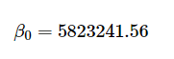  
The price of an aircraft with jet engine type is $5.8 million when all the other predictors are zero. (This is not valid in real life)

#### **Main Effects of Qualitative variable :**

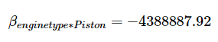

Aircraft with a Piston engine are, on average, $4.4 million cheaper than the aircrafts with Jet engine type holding all other variables constant.

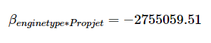

The price of an aircraft with a Propjet engine is $2.8 million lesser than the jet engine type aircrafts. Still cheaper, but not as much as a piston plane.

#### **Main effects of Quantitative variable:**

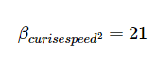

The squared term suggests a nonlinear relationship between cruise speed and price. For a 1 unit increase in cruise_speed, the price increases by 21 $cruisespeed^{2}$*, indicating that price rises more steeply at higher cruise speeds.

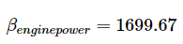  
A 1-horsepower increase in engine_power price jump by $1,699.67, reflecting the value of greater power. We know —stronger engines aren’t cheap.

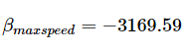  
For every 1 knot increase of max speed, the price drops by $3,170. usually Faster planes should cost more but here this effect is tangled up with other factors we will get to—like interactions.

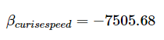  
A 1-knot increase in cruise speed decreases price by $7,505.68

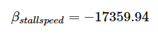  
If the stall speed goes up by a one knot, the price drops by $17,360.

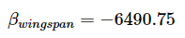  
A 1-inch increase in wingspan decreases price by $6,491.

### Main effect on Interaction Terms with Engine Type:

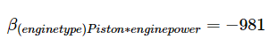  
For Piston engines, each additional horsepower reduces the price from engine_power by $981 compared to the jet engine type. Net effect for Piston: 1,699.67 − 981 = 718.67 dollars per horsepower.

For Propjet engines, each horsepower reduces the price by $2,284.54.

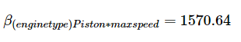  
For Piston engines, a 1-knot increase in max speed increases price by an additional $1,570.64 over the reference. Net effect: −3,169.59 + 1,570.64= −1,598.95 dollars per unit.With piston engines, a knot increase of max speed cuts the price drop to $1,599.

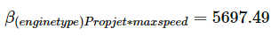  
For Propjets, a 1-knot increase in max speed adds $5,697.49 to the price of the aircraft. Net effect:  
−3,169.59+5,697.49 = 2,527.90, indicating higher max speed boosts price for Propjets.

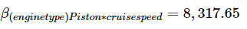

For Piston engines, a 1-knot increase in cruise speed adds $8,317.65. Net effect: −7,505.68 + 8,317.65= 811.97 dollars per unit.Here, a knot increase of cruise speed adds $812 to the price for aircrafts with piston engine.

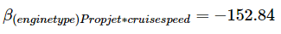  
For Propjets, a 1-knot increase reduces the cruise speed effect by $152.84. Net effect:  
−7,505.68 − 152.84= −7,658.52.For propjets, cruise speed still reduces the price ,by $7,659 per knot.

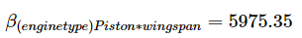  
For Piston engines, a 1-inch increase in wingspan adds $5,975.35 to the aircraft price.  
Net effect: −6,490.75+5,975.35= −515.40. Piston planes soften the wingspan price drop to about $515 per inch.

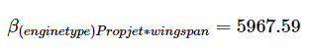  
For Propjets, a 1-inch increase in wingspan increases the aircraft price by $5,967.59.  
Net effect: −6,490.75 + 5,967.59=−523.16. Propjet planes soften the wingspan price drop to about $515 per inch.

### **Main effect of Quantitative Interaction Terms:**

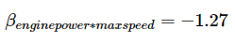

For a 1-knot increase in max speed, the effect of engine power on price decreases by $1.27 per horsepower.

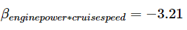

For a 1-knot increase in cruise speed, the effect of engine power on aircraft price decreases by $3.21 per horsepower.

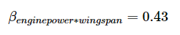  
For a 1-inch increase in wingspan, the effect of engine power on aircraft price increases by $0.43 per horsepower.

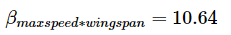  
For a 1-inch increase in wingspan, the effect of max speed on aircraft price increases by $10.64 per knot.

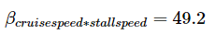  
For a 1-knot increase in stall speed, the effect of cruise speed on price of the aircraft increases by $49.2 per knot.

### **3.5 Confidence Interval Estimation**



Figure 3.22 R code for estimating confidence interval with 95% confidence level

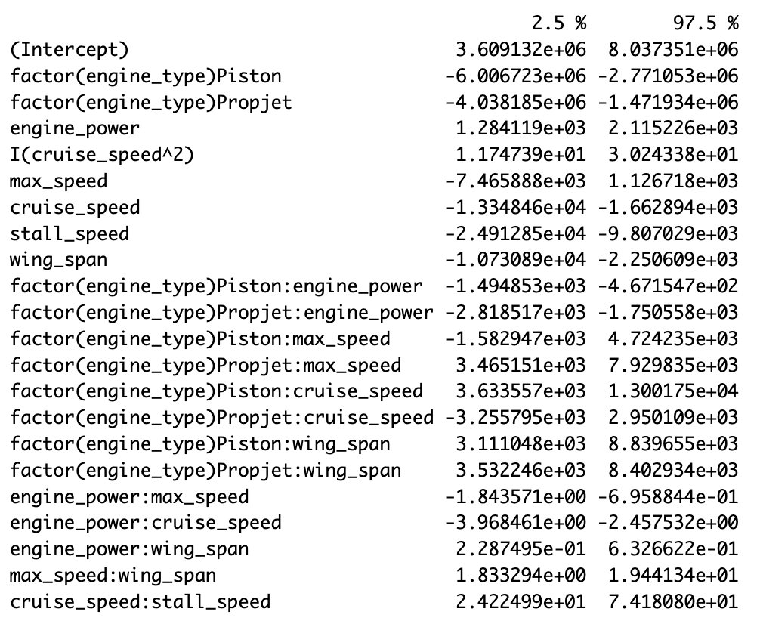

Figure 3.23 Confidence intervals for coefficients

Our model identifies key drivers of aircraft price, with engine type, engine power, cruise speed, stall speed, and wing span playing significant roles. Engine power increases price, while stall speed and wing span tend to decrease it. Notably, Propjet aircraft benefit more from higher speeds and larger wingspans. The most significant predictors are cruise speed, engine power, and cruise speed squared. We are 95% confident that for every one-unit increase in cruise speed, price decreases by 1,660 to 13,300, while engine power increases price by 1,280 to 2,120 per unit. Additionally, the quadratic cruise speed term shows a nonlinear price effect, meaning price increases at higher cruise speeds but at a diminishing rate.

### **3.6 Model Prediction**

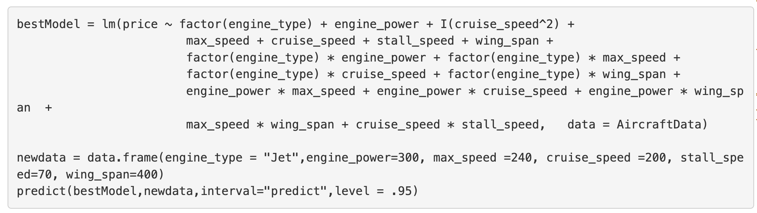



From the prediction results, the model estimates a fitted price of 2,577,134 USD for a jet aircraft with the given specifications: engine_power = 300, max_speed = 240, cruise_speed = 200, stall_speed = 70, and wing_span = 400. The 95% prediction interval ranges from 1,858,573 USD (lower bound) to 3,295,694 USD (upper bound).

**3.7 Checking the remaining Regression Assumptions**

### **3.7.1 Linearity Assumption**

### The linear regression model assumes that there is a straight-line (linear) relationship between the predictors and the aircraft price. For identifying the non-linearity we are using the residual plot.

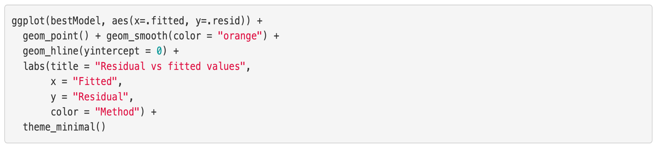

Figure 3.22 R code for plotting Residual vs fitted values

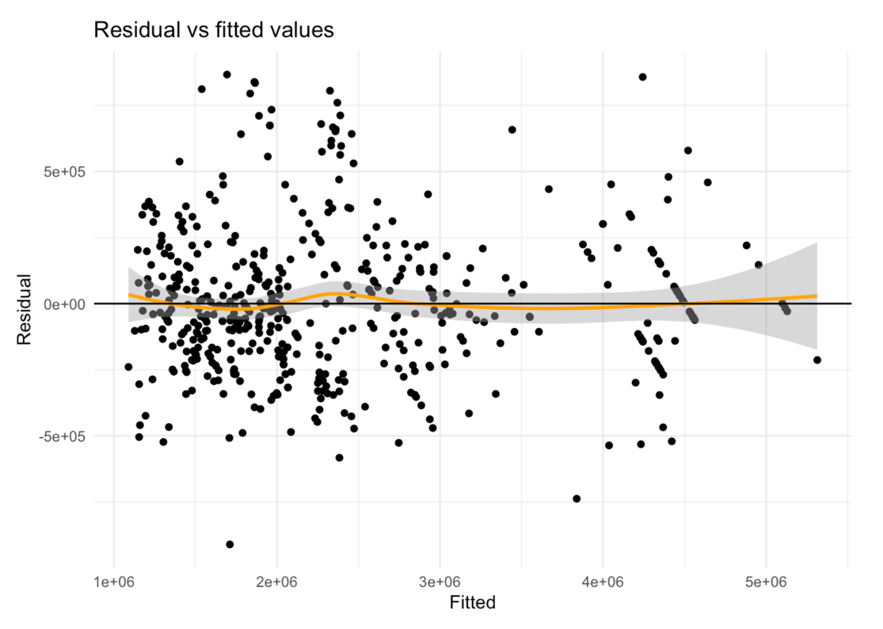

Figure 3.23 Residual vs fitted values Plot

There appears to be no pattern of the residuals at all. The 𝑅2𝑎𝑑𝑗 of the bestModel is 0.9247535 indicates the variation in Price that can be explained by this model is 92.48% with RMSE = 279449.2. We can conclude that the above model named bestModel, is the best fit model to predict Price among the models we considered.

We will now extract the residuals and plot this data to analyze the histogram, qq plot, and residual vs fitted plot.

#### **Histogram of Residuals**

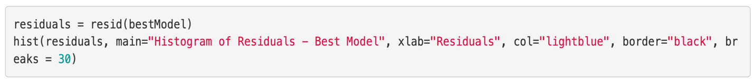

Figure 3.24 R code for plotting histogram for residuals

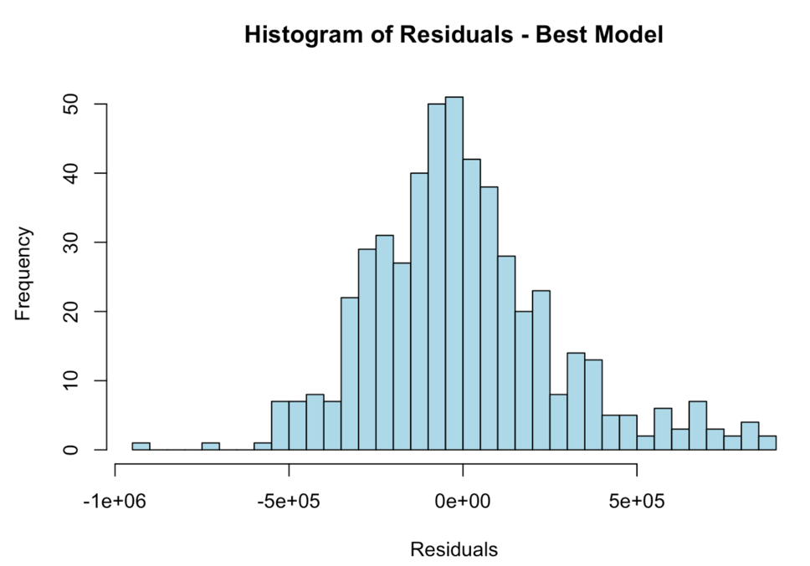

Figure 3.25 Histogram - Residuals

The histogram appears to be somewhat centered around zero, which is good. However, the shape does not perfectly follow a bell curve (normal distribution). The bars are somewhat skewed—there seems to be a longer right tail, suggesting potential positive skewness. Next, we will confirm whether the residuals deviate from normality, using the Q-Q Plot.

#### **Q-Q Plot of Residuals**

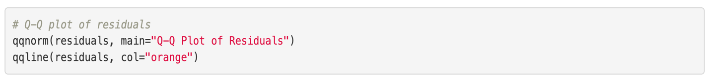

Figure 3.26 R code for Q-Q plot

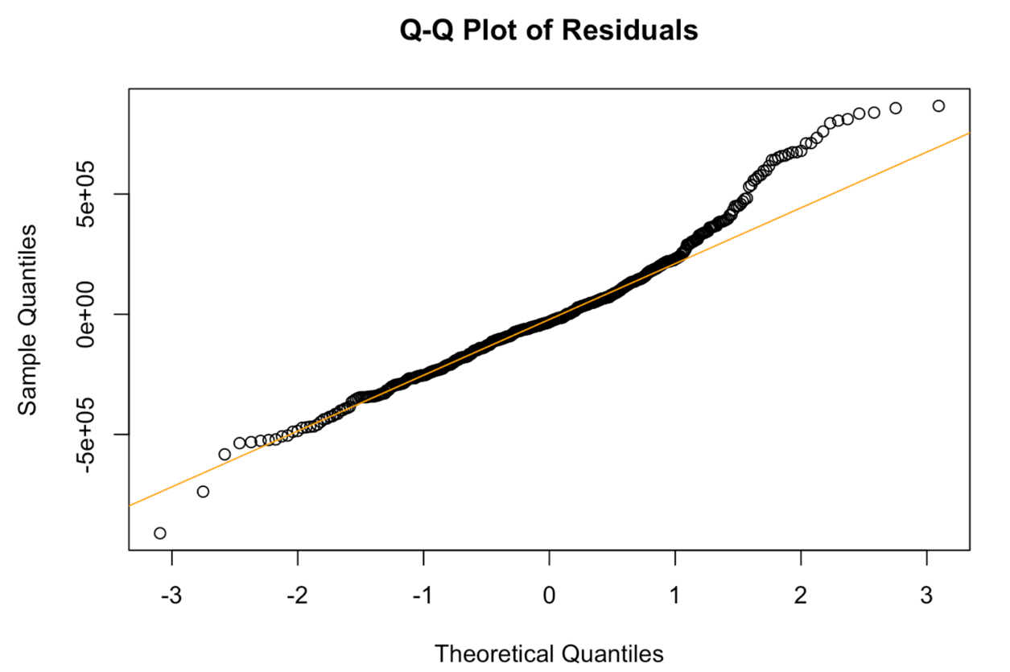

Figure 3.27 QQ plot

The points have a slight deviation at both ends (left and right tails), indicating non-normality in the residuals. The right tail (higher values) has several points far above the line, suggesting the presence of high-value outliers (potentially high-priced aircraft affecting the model). The left tail (lower values) slightly deviates as well. Most points near the center follow the orange line well, which means most residuals are approximately normal.

### **3.7.2 Independence Assumption**

In linear regression, the error terms (𝜖₁, 𝜖₂, 𝜖₃, etc.) should not be related to each other. This means the value of one error doesn’t give any clue about the next one. When this assumption is violated (e.g., errors are correlated), it often happens in time-series data, where observations are taken over time. As we do not have any time series data or spatial variable, we considered to plot the residuals vs engine_type category.

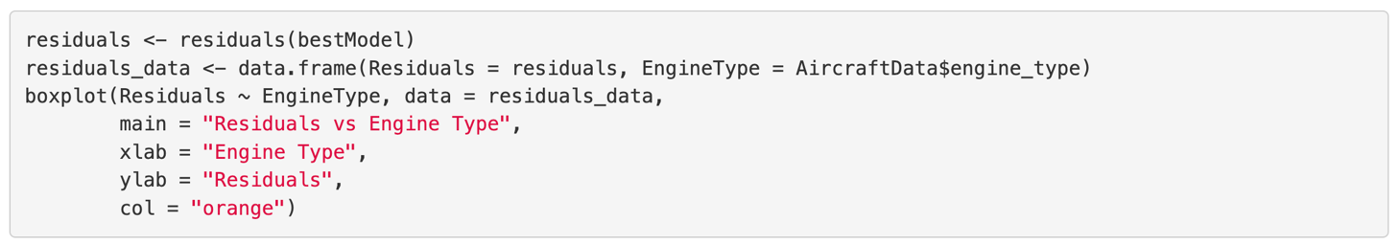

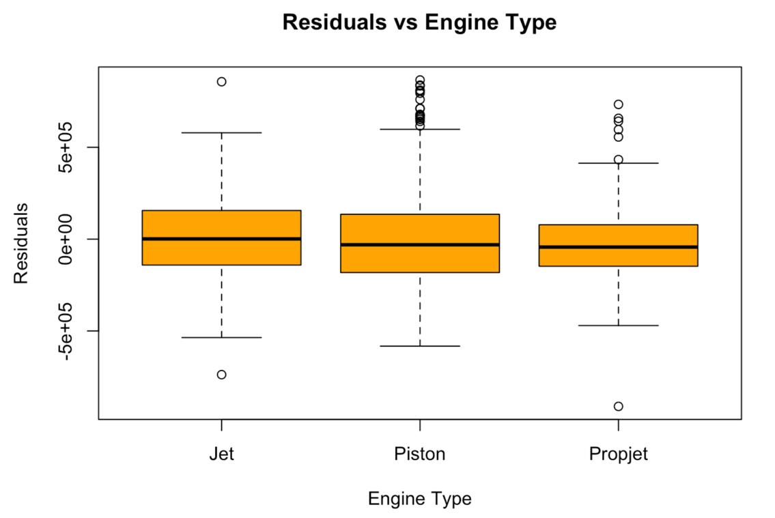

Figure 3.28 Boxplots- Residuals for different Engine Types

The box plot above indicates that the residuals for different engine types are centered around zero and do not display any noticeable patterns. Therefore, the independence assumption is satisfied.

### **3.7.3 Equal Variance Assumption**

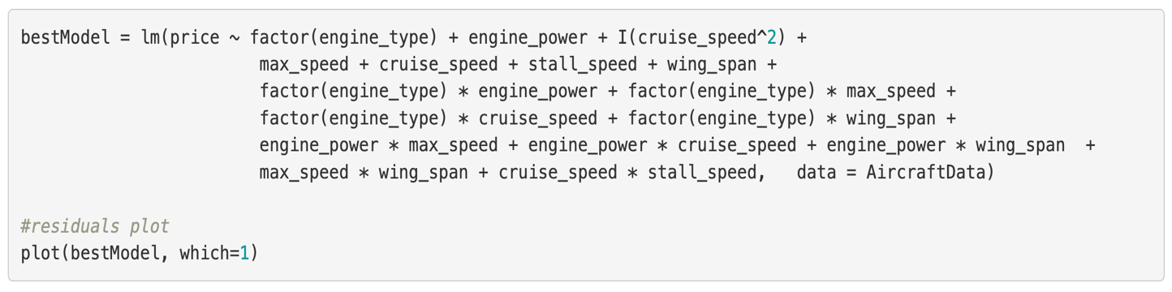

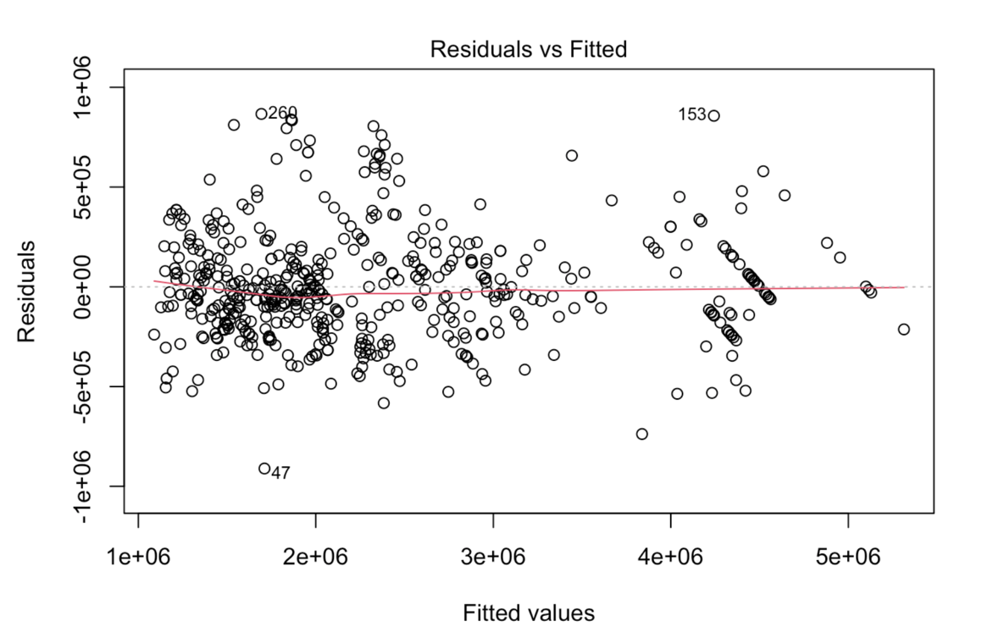

Figure 3.29 Scatterplot- Residuals vs Fitted Values



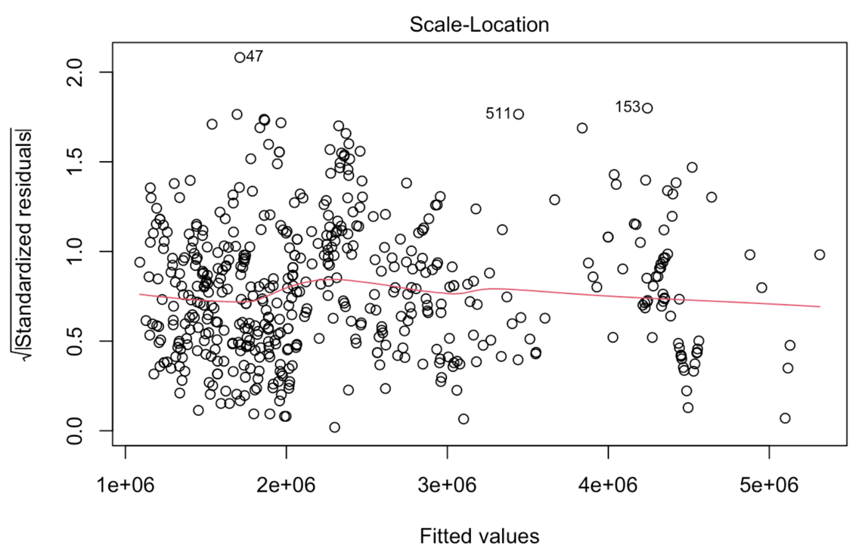

Figure 3.30 Scale-location plot

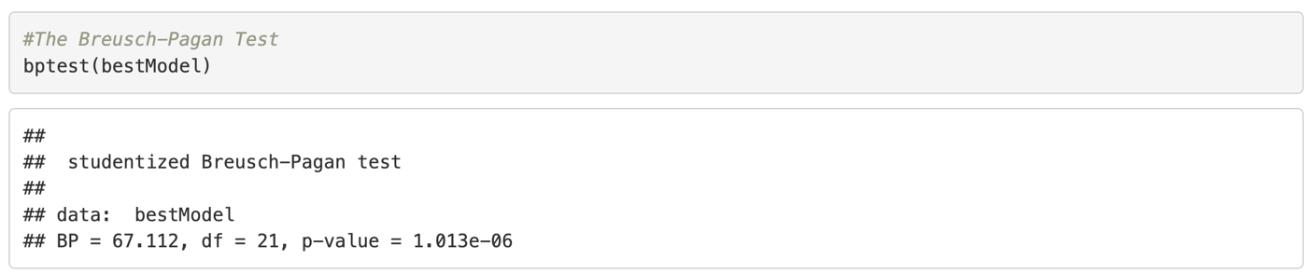

H0: heteroscedasticity is not present (homoscedasticity)

H1: heteroscedasticity is present

Here we reject the null hypothesis (p-value < 0.05), so we conclude we do have heteroscedasticity. Maybe we can try a higher order model to get rid of this issue.

To resolve we can apply log transformation

### **Log transformation**

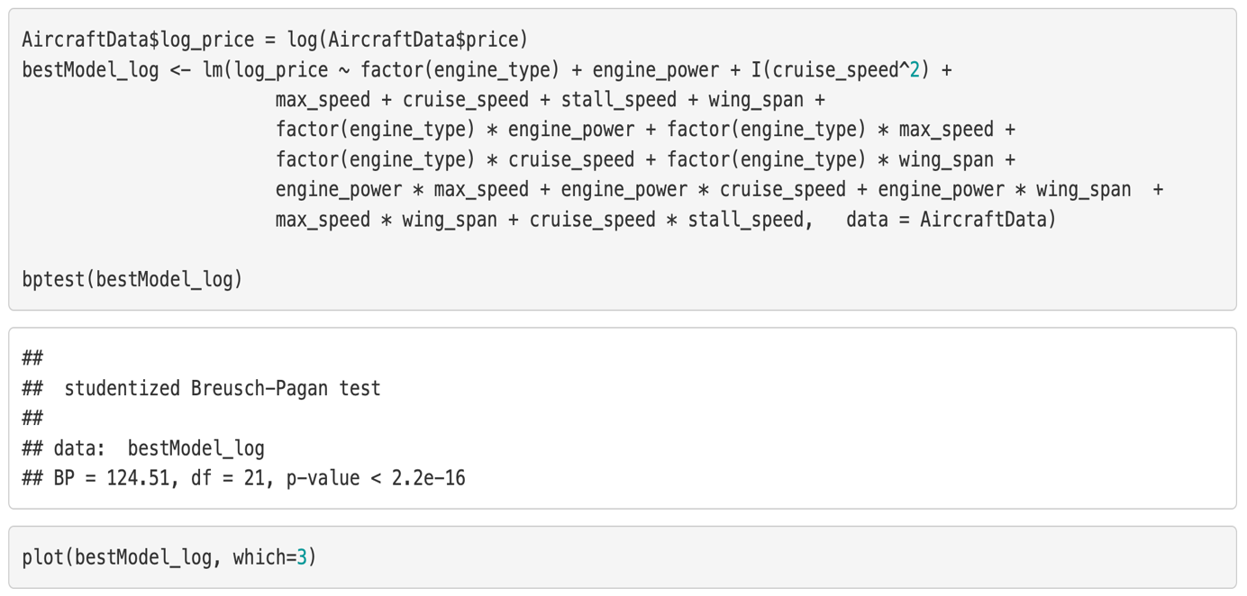

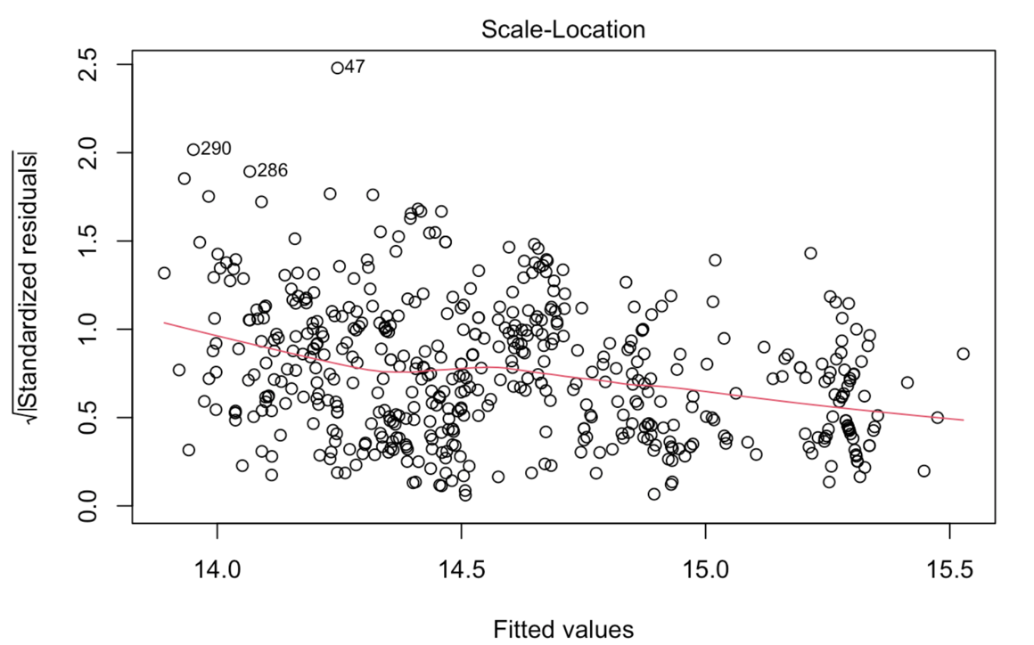

Figure 3.31 Scale location plot

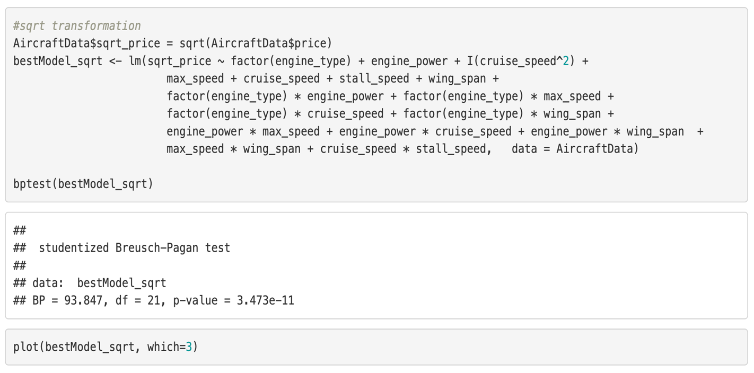

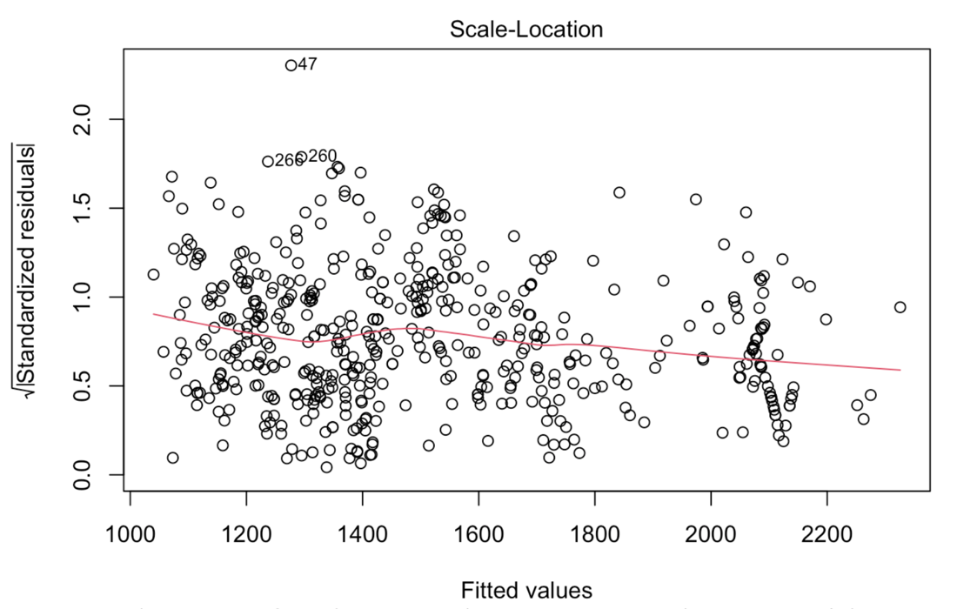

Figure 3.32 Scale location plot

p-value < 2.2e-16 is less than 0.05, so we reject H0. Therefore, there exists hetroscedasticity. Now we apply Box-Cox transformations.

### **Box-Cox transformations**



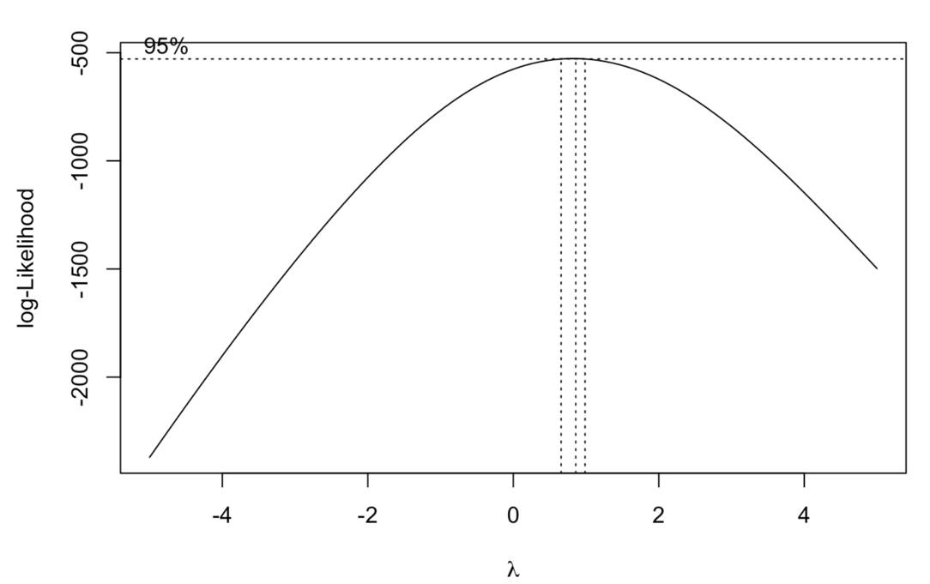

Figure 3.33

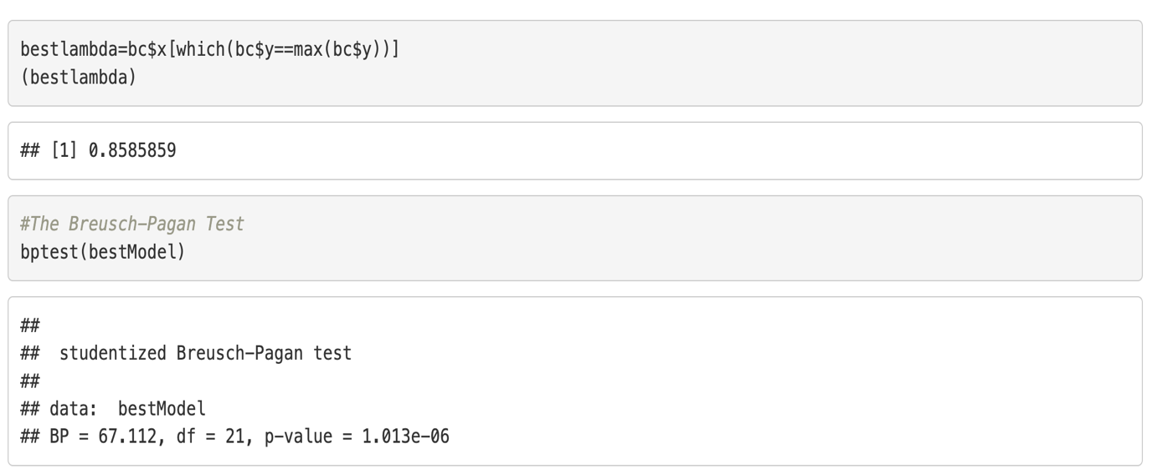

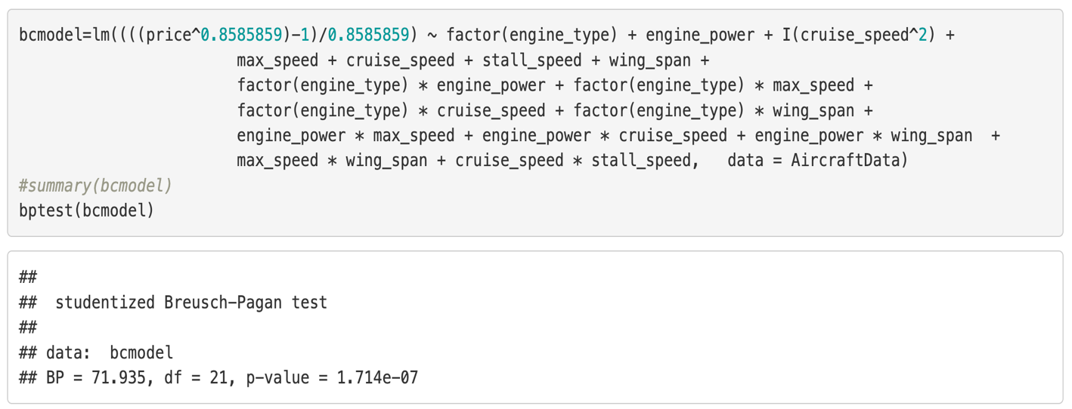

The Box-Cox transformation (using λ = 0.8586) helped to adjust the dependent variable, but it did not completely solve the heteroscedasticity problem in the model.

### **3.7.4 Outliers**

We use the below R code for plotting outliers.

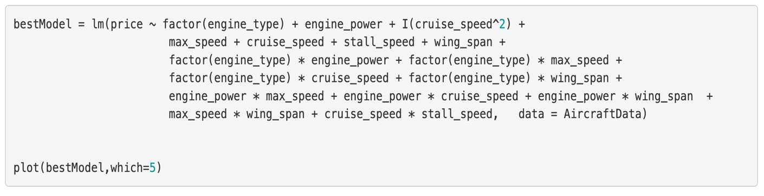

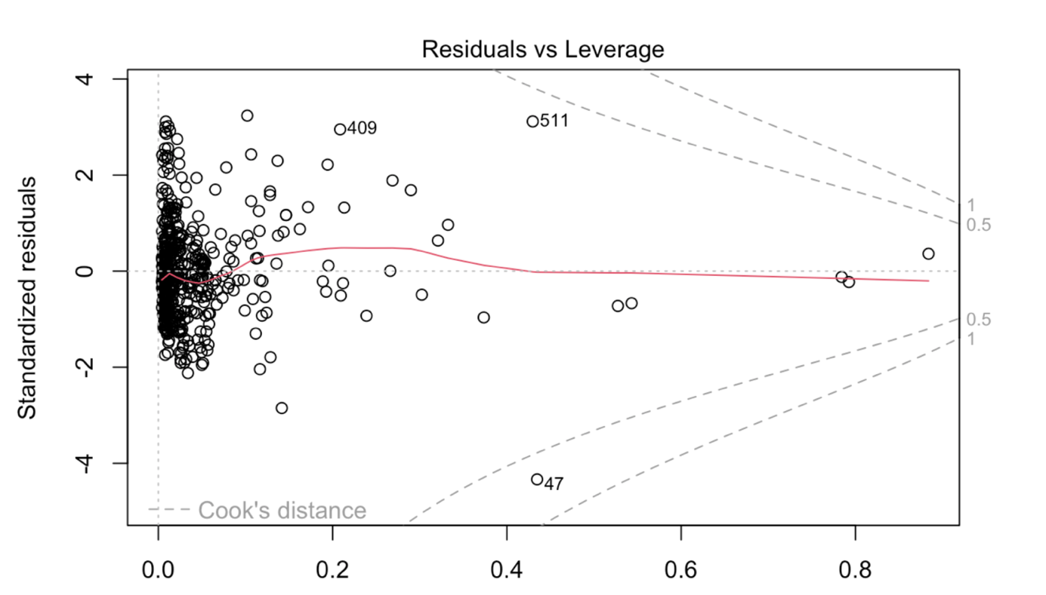

Figure 3.34 Residuals vs Leverage Plot

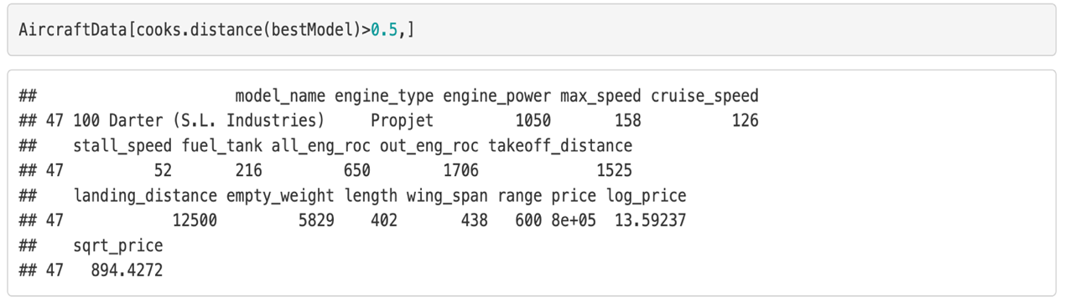

Now we have to visualise the Cook distance’s plot.



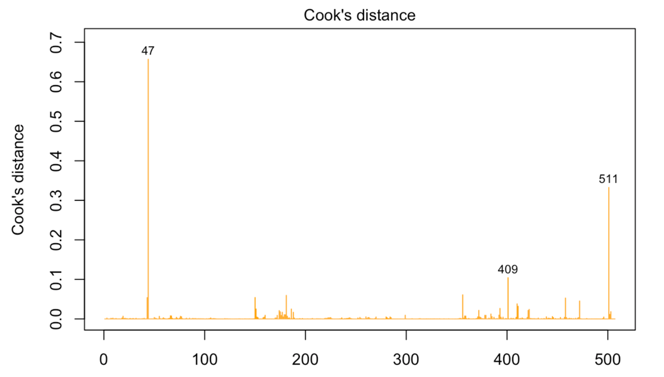

Figure 3.35 Cook's distance plot

We can see that data point 47 is an influential case and we need to work for that point so find cook distance. Observation 47 (0.65) well above this threshold, indicating they are highly influential points.

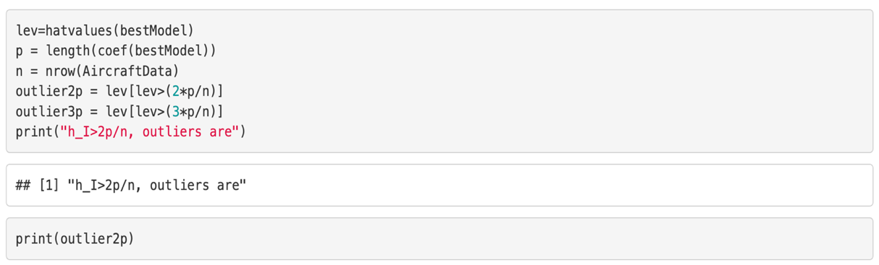

Here 47 leverage point is 0.4346 and cook distance 0.65 so this is high influential points and remove and check the result.

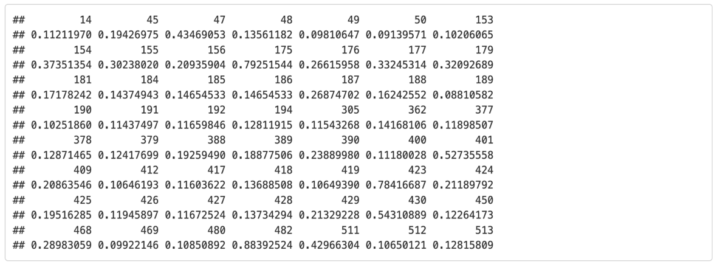

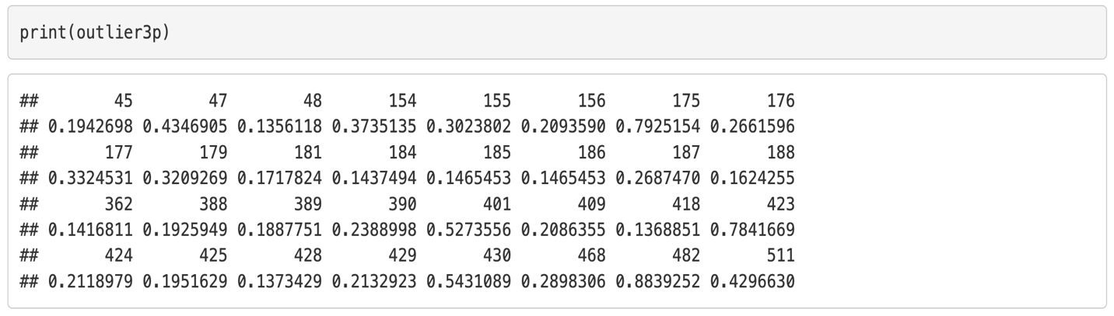

After removing the outlier, we created the model and checked the Adjusted R^2 and RSE values of the new model.

Adjusted R^2 value of the new model is 0.9273 and RSE is 274264.5. This shows that the removal of outliers has improved our model.

**Key Findings**

Our best model predicts aircraft price based on engine type, performance metrics such as cruise speed, engine power, stall speed, max speed, and design factors like wing span. On analysis of the best model, we can see the below findings:

**Engine Type:**

Jet type is the reference category

Piston price is less than Jet by approximately 4.39 million USD

Propjet price is less than Jet by approximately 2.76 million USD

**Cruise Speed impact:**

Linear term: negative effect on price

Quadratic term: positive effect with exponential price increase at higher speeds

Negative Effects: for stall speed and wing span

**Interaction terms:**

For Propjets, Higher max speed benefits, but higher cruise speed reduces price.

Engine Power + Max Speed / Cruise Speed: Slight negative price impact

Max Speed + Wing Span: Contributes positively to price

**Jet Engines**: Predicted price is 5,823,241.56 USD when all other variables are zero. Jets do not experience price reductions like piston engines or propjets. Negative effects come from stall speed and wing span, with mixed interactions across other factors.

**Piston Engines**: Predicted price is about 4.39 million USD lower than jets. Engine power decreases price by 981 units per unit increase, while max speed and cruise speed positively impact price. Greater wing span also increases price, but stall speed and wing span have overall negative effects.

**PropJets Engines**: Predicted price is approximately 2.76 million USD lower than jets. Engine power reduces price by 2,284.54 units per unit increase, but max speed and wing span increase price. Higher cruise speed slightly decreases price, while stall speed and wing span have negative effects.

1. **CONCLUSION AND DISCUSSION**
   1. **Approach**

We could have split our data into test data and training data and should have worked on it. Then we could have tested the accuracy of our predictions. Since we used all rows of our dataset for training, prediction accuracy cannot be verified using real world data.

We tested the data for multicollinearity first and then created the best model and tested the rest of the assumptions on the model. This made our model selection easier, but some of the assumptions for linear regression model were not satisfied. A different approach was to test all the assumptions before model buildings.

**4.2 Future Work**

**4.2.1 To address heteroskedasticity for Equal Variance**

Since the best model has not meet with homoscedasticity or equal variance assumption. It could be resolved by doing some of the following methods:

* Appropriate transformation of dependent variable (other than log, sqrt. Since we tried it)
* Use WLS instead of Ordinary Least Squares (OLS) to assign weights to observations inversely proportional to their variance.
* Check for omitted variables by introducing variables may help capture the relationships causing heteroscedasticity
* Identify and consider removing influential observations or outliers that might cause variance issues.

**4.2.2 Reduction of terms with VIF > 5**

Given that the predictors engine_power and cruise_speed are statistically and theoretically significant for our dataset, we chose to retain them despite their VIF being greater than 5. While these terms hold theoretical importance, removing them might yield alternative models capable of predicting prices effectively. Further analysis is necessary to evaluate their relevance, and we suggest examining whether the newly developed model could address the heteroscedasticity problem.

1. **REFERENCES**
2. James, G., Witten, D., Hastie, T., & Tibshirani, R. (2021). *An introduction to statistical learning* (2nd ed.). Springer. <https://www.statlearning.com/>
3. Aircraft Price Analysis & Prediction Dataset. (2024, December 9). Kaggle. <https://www.kaggle.com/datasets/mehmet0sahinn/aircraft-price-analysis-and-prediction-dataset?resource=download>
4. Al-Shamma, O., & Ali, R. (2024). Parametric cost prediction models for light general aviation aircraft in the early design phase. *Mathematical Modelling and Engineering Problems*, *11*(9), 2293–2302. <https://doi.org/10.18280/mmep.110902>
5. Lee, D., & Jin, W. (2013). Prediction of Commercial Aircraft Price Using the COC & Aircraft Design Factors. *Procedia Engineering*, *67*, 70–77. <https://doi.org/10.1016/j.proeng.2013.12.006>
6. *Jet & Piston single aircraft asking prices see yearly & monthly declines amidst steady inventory growth*. (n.d.). Controller.com. <https://www.controller.com/blog/sandhills-news/2024/09/jet-and-piston-single-aircraft-asking-prices-see-yearly-and-monthly-declines-amidst-steady-inventory-growth>